Learning Computer Science Concepts in Scratch
Department of Science Teaching
Weizmann Institute of Science

Copyright 2012 by Orni Meerbaum-Salant, Michal Armoni, Moti Ben-Ari.
This work is licensed under the Creative Commons Attribution-NonCommercial-ShareAlike 3.0 Unported License. To view a copy of this license, visit http://creativecommons.org/licenses/by-nc-sa/3.0/ or send a letter to Creative Commons, 444 Castro Street, Suite 900, Mountain View, California, 94041, USA.

Posttest

Question 1
Here is a diagram of the stage with four sprites (giraffe, elephant, mouse, ball), together with scripts for each of the sprites:
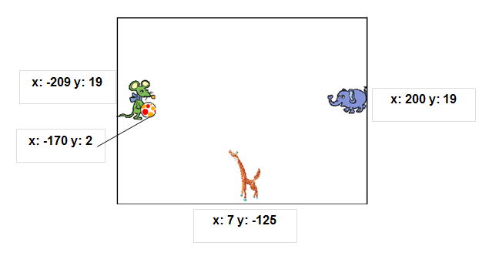

Mouse script | Elephant Script | Giraffe Script | Ball Script
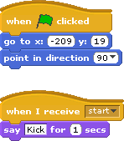 | 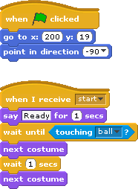 | 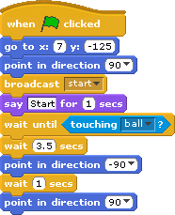 | 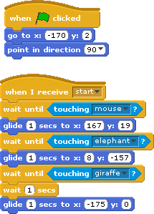

- (Multi Applying) What operations take place concurrently until the instruction in the script for the giraffe is run?
- (Multi Understanding) What is the difference between the instructions and ?
- (Relational Applying) Describe the behavior of the animals and the ball when (all) the scripts are run after clicking on the green flag.
- (Multi Creating) We wish the animation to be repeated indefinitely without clicking again on the green flag. What instruction or instructions must be added? (Add instructions only to scripts that actually need additional instructions for this to happen.)
- (Multi Creating) Add a variable “counter” to the animation. It will count the number of times that the ball is passed from one animal to another.
Question 2
- (Relational Creating) Create an animation for two sprites that will initially be placed at two corners of the stage. One sprite will send a message to the other. When the second sprite receives the message ,
the two sprites will exchange places by gliding .
- (Relational Creating) Modify the animation so that when the two sprites touch each other, they will exchange greetings.
- (Multi Creating) Add instructions so that the sprites exchange places five times.

Question 3
(Multi Understanding) Explain the following concepts. Your explanations may contain examples that are Scratch instructions.
- Initialization
- bounded repeated run
- conditional repeated run
- conditional run
- sending and receiving a message
- variable
- concurrent run

