Learning Computer Science Concepts in Scratch
Department of Science Teaching
Weizmann Institute of Science

Copyright 2012 by Orni Meerbaum-Salant, Michal Armoni, Moti Ben-Ari.
This work is licensed under the Creative Commons Attribution-NonCommercial-ShareAlike 3.0 Unported License. To view a copy of this license, visit http://creativecommons.org/licenses/by-nc-sa/3.0/ or send a letter to Creative Commons, 444 Castro Street, Suite 900, Mountain View, California, 94041, USA.

Interim test

Question 1
Here is a script for the cat sprite:
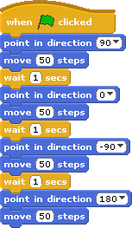
- (Multi Applying) How many steps will the cat take from the time the green flag is clicked until the end of the script?
  - 0
  - 50
  - 90
  - 200
- (Uni Applying) In what direction does the cat face at the end of the script?
  - -90
  - 0
  - 90
  - 180
- (Multi Applying) Draw the path that the cat takes when the script is run.

- (Multi Creating) Add instructions to the script so that the cat will move in the path described by the figure:

Question 2
Here is a script for the cat sprite:
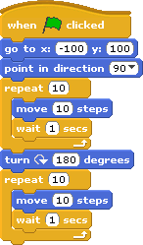
- (Uni Applying) What is the position (coordinate) of the cat after the green flag is clicked and the first instruction is run?
- (Multi Applying) What is the position (coordinate) of the cat after the entire script is run? In what direction is the cat facing?
- (Multi Applying) How many times is the instruction run?
- (Uni Creating) Add an instruction to the script so that the cat never stops.

Question 3
Here is a script for the cat sprite:
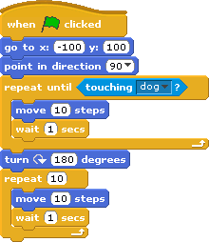
- (Multi Applying) If the dog sprite is at position x=100, y=100, how many times is the instruction run?
- (Uni Creating) Change the script so that the cat changes his direction only when he reaches the edge of the stage.
- (Uni Creating) Change the script you created in the previous question so that when the cat reaches the edge of the stage he says “Oh” for 2 seconds.

