Our good friend John is a champion sand-castle builder. He won every competition in Europe. But one day he went to a competition in Australia and all he got was this magic sand. At first he was convinced he would lose. But guess what, he built a sand castle after all!!  Now it's your turn - can you? | 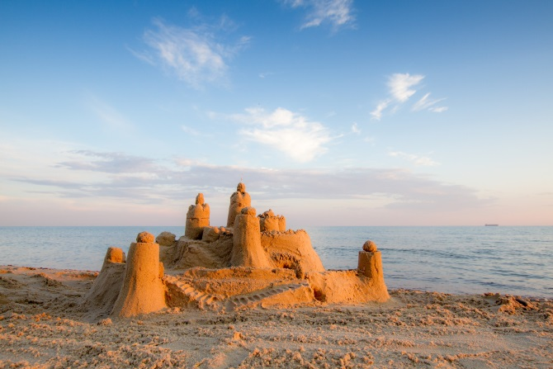
Engage
Task: | John provided us with two types of sand:  regular and special sand.  Add some drops of water to each to see what John saw when trying to build the sand castle in Australia.
Explore
Task 1: | Try building a sand-castle from the special sand.  Do you need any extra tools or materials?
Task 2: | Explore the behavior of the sand with the tools and materials you requested.
Explain
Task 1: | Explain: What are the properties of the "special" sand that prevent water from wetting it?
Task 2: | What do you think is the chemistry underlying the "special" sand?
Task 3: | Look at the model representing the surface of regular sand at the molecular level.  How can you explain the fact that water wets this sand? 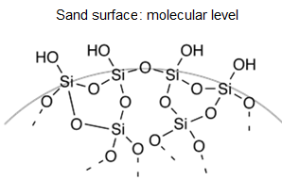  Credits:http://commons.wikimedia.org/wiki/File:Schematic_silica_gel_surface.png

Extend
Task 1: Write five questions that arose while exploring the "special" sand?
Task 2: Choose one of the questions that you would like to investigate regarding the "special sand castle" and formulate this question clearly as an inquiry question?

Task 3: Clearly formulate a hypothesis that relates to the question that you chose to investigate. Give reasons for your hypothesis, based on correct and relevant scientific knowledge.

Task 4: Plan an experiment that will check your hypothesis.
• Detail all the steps of the experiment, including the control stage.
• List the equipment and materials needed on the equipment request form.
• Consult with the teacher and make changes if necessary.
• Submit the list of equipment and materials to the laboratory technician.
Evaluate
Task:
Prepare a lab report.
The results and conclusions can also be presented in a dramatic way.

