PROFILES IBSE Teaching/Learning Materials – Overview
Compiled by the PROFILES Working Group of the Weizmann Institute of Science, Israel

Plastic: Reduce the use!
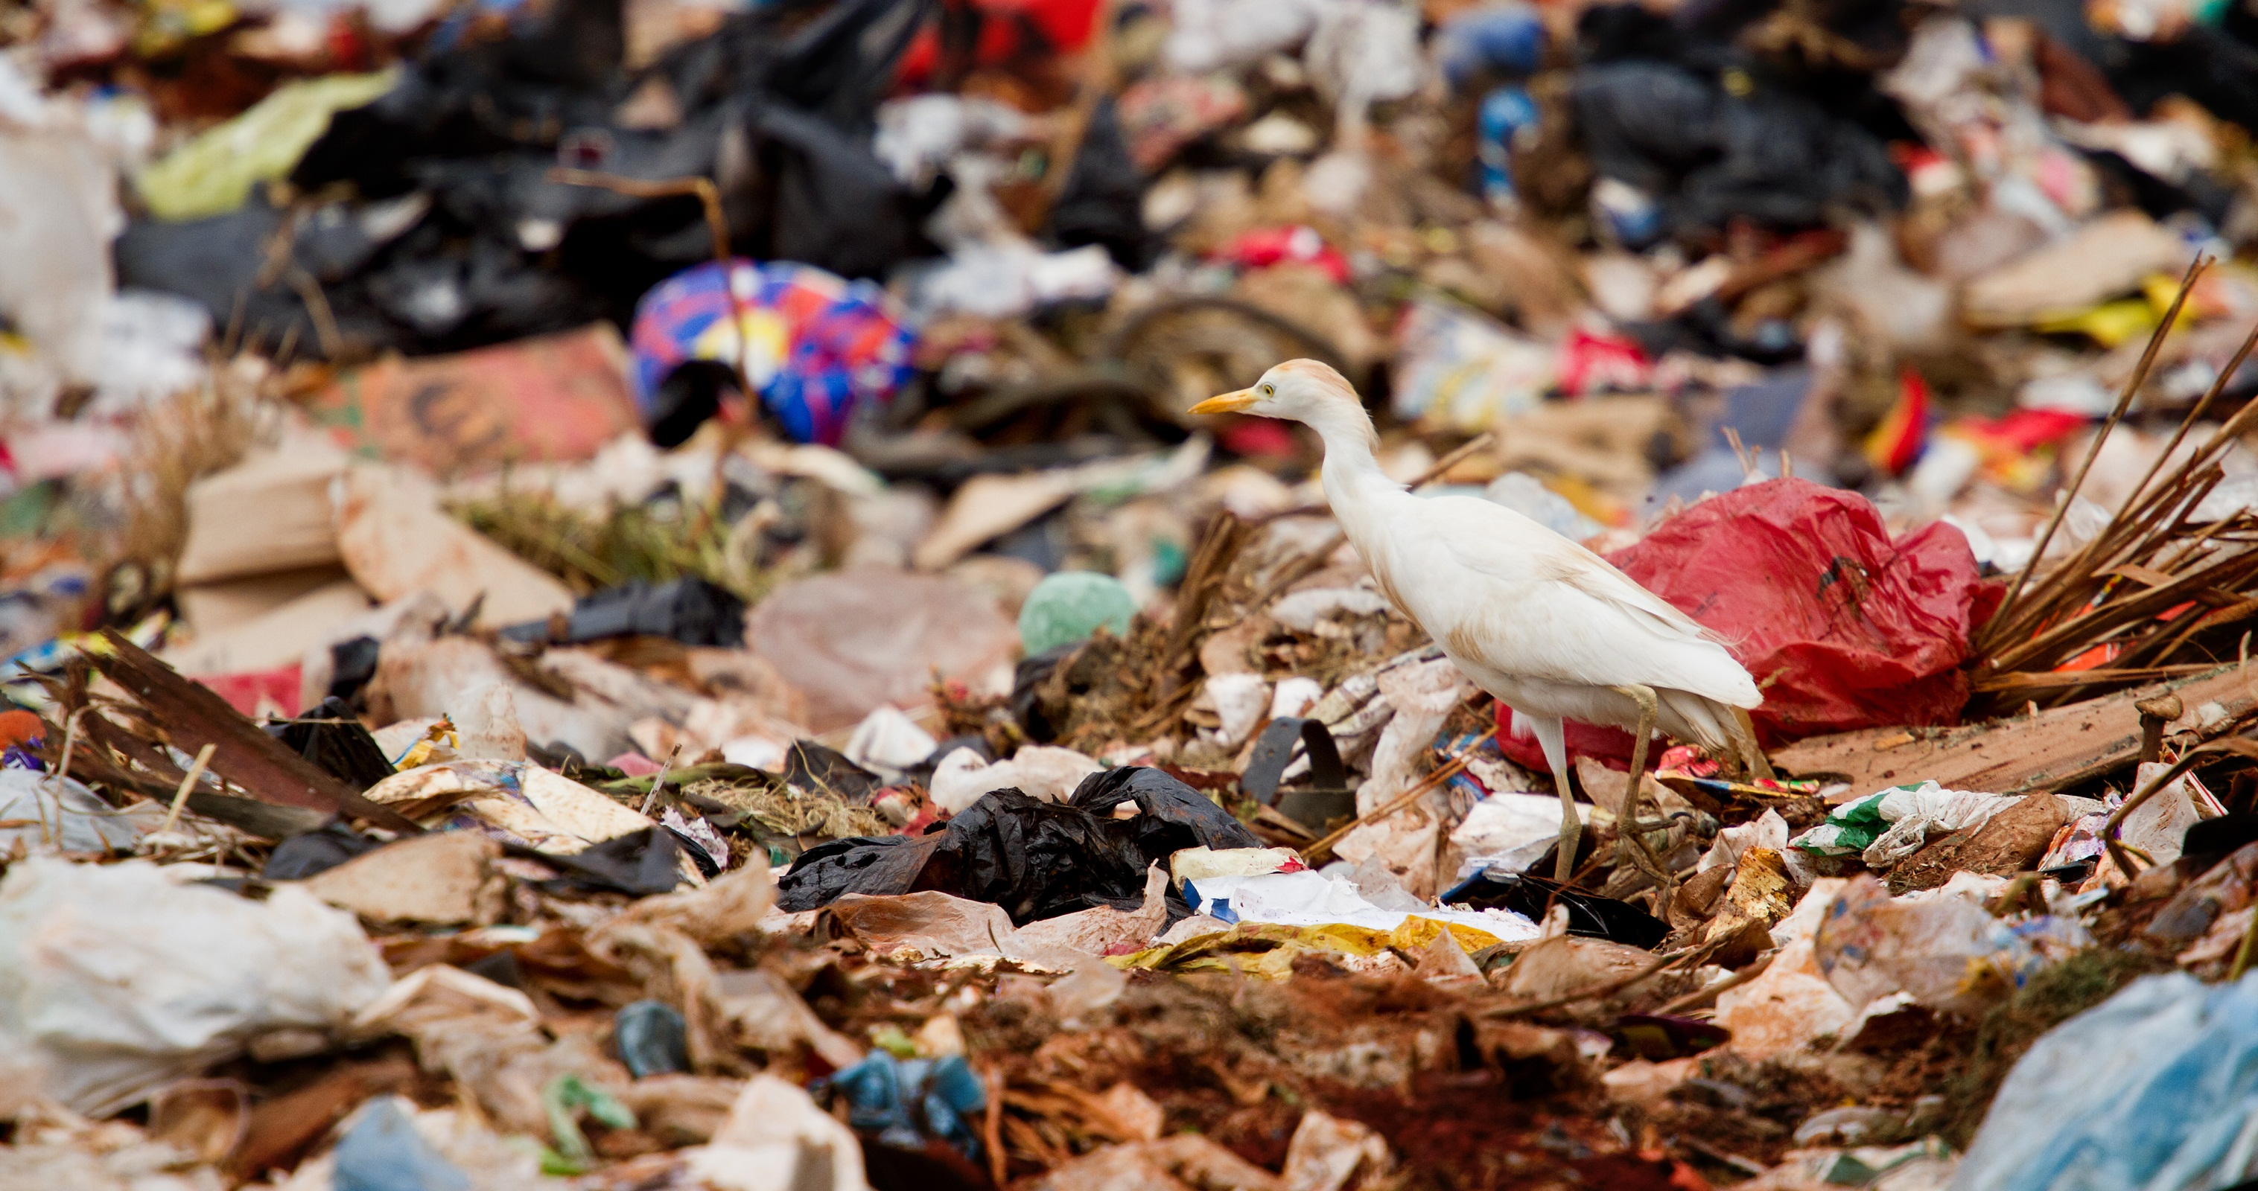
A module on plastic products: structure, and environmental impact for Grades 10 to 11

Leaders: Avi Hofstein and Rachel Mamlok-Naaman
Developed by: Sandra Azuelos-Kats, Afrah Assi, Pavel Kuzmin.
Edited by: Dr. Dvora Katchevich and Dr. Rachel Mamlok-Naaman.
Institution: Science Teaching Department, the Weizmann Institute of Science – Israel
Homepage: http://stwww.weizmann.ac.il/g-chem/profiles/

Plastic: Good or bad?

Opening: Picture interpretation
Split into groups of 4 students, get a picture from the teacher, and answer the following questions :
A. What is your impression of the picture?
B. What do you feel when you look at the picture?
C. Does it bother you to see the picture? If so,why? If not, why?
D. What would you like to do after you've seen the picture? Note anything that you can think of

Activity number (1): P.P.P.
Watch the attached P.P.P (Power Point Presentation)

Activity number (2): Reading a story
Read the story " A sad story that happened on the beach". Dr. Jeremy Klein and answer the questions presented below.

One Saturday, when Roy and his father were walking on the beach on the Hasharon coast, Roy noticed something lying a few dozen meters in front of them. Roy started running towards to the unidentified thing, but his father stopped him. "Slowly," said his father, "You never know what we will encounter." They approached cautiously toward the dark mass and Roy suddenly shouted: "This is a " sea turtle". It looked completely exhausted. When the turtle saw them, he tried to move a little, but barely could do it. Roy's father called the police, and they gave him the emergency telephone number of the Turtle Rescue Center - in Mikhmoret. After half an hour, during which Roy and his father were asked to spray seawater on the turtle, two guys came from the center. These were the center's director Yaniv and the veterinarian Gil. With several people who gathered on the beach they moved the turtle into a large car and drove him to the Turtle Rescue Center. The veterinarian Gil infused fluid infusion into the turtle, in order to try and save him. He claimed:. "This is a Gladi sea-turtle, one of the three most common turtles in the Mediterranean Sea.
He is exhausted and has trouble breathing. Apparently he was laying on the beach a few hours before we found him, and certainly did not eat for days, "said Yaniv." Can we save him? ", Roy asked anxiously.
"The truth is that it looks very bad, but we will try," said Gil.

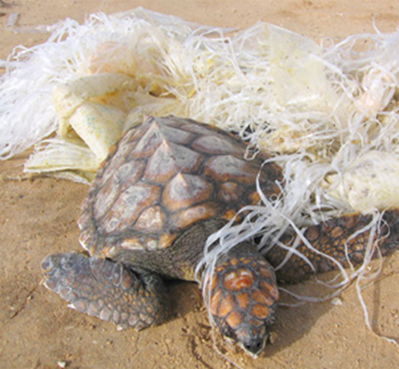
Gil wore an Oxygen mask on the face of the turtle and said: "According to my experience, I think that the turtle is choking from something that he swallowed. We will have no other way but conduct a surgery, which may take several hours. Therefore, you should go back home and we will update you about the situation. During the surgery, Gil removed from the turtle stomach a large bag of thick plastic.
As promised, he called Roy and informed him that the surgery was successful. "You would not believe if you see what we got from the stomach of the turtle. When he will recover you will be able to visit him". Roy was happy. A few days later Roy came to the rescue center in Michmoret to visit the place. He hugged Gil and Yaniv and thanked them very much: "We need to thank you for the attention. You did the right thing. Please continue to keep an eye on the beach. And most importantly, Roy, tell the class what happened. It is important that everyone will learn that throwing waste into the sea must stop ". After a few weeks he invited Roy and his father to watch the release of the turtle back to the sea.

Questions for discussion:
- Name the story you just read. Why did you choose this name?
- Who is responsible for the damage of the sea turtle?
- Why do you think it was necessary to establish in Michmoreta Turtle Rescue Center?
- What must we do in order to prevent damage to living creatures and to the shores of our country?
- Why is food not a problem when taken into the stomach, but plastic bags are?
- How can plastics bags be made harmless after use?
- Why are plastics so resistant to change/decomposition?

Activity number (3): Carrying out two experiments:
- Experiment (A) : Nylon production
- Experiment (B) : Water solubility test :
- Poly-vinyl-alcohol
- Polyethylene

Experiment (A) - Nylon production
Materials and equipment:
- 4cc of 1, 6 hexanediamine solution.
- 4 cc of sebacoyl chloride solution
- Tweezers
- Glass rod
- Chemical glass
Performing the experiment:
- Replace the 4cc of 1, 6 hexanediamine solution in the bottom of the chemical glass.
- Add slowly 4 cc of sebacoyl chloride solution to the chemical glass.
- Use the tweezers and grope the layer. Pull it out and roll it on the glass rod.
Write down your observations.
Watch the attached link below:
http://www.youtube.com/watch?v=c7ihpZhCj6k
Experiment (B) - water solubility test.
Materials and equipment:
- Polyethylene bags P.E.
- poly- vinyl-alcohol PVA
- Chemical glasses
- A glass rod
- Water
Performing the experiment:
1. Put a piece of polyethylene bag 10x10cm in 100ml of water. Mix with glass stick.
2. put a piece of poly-vinyl-alcohol 10x10cm in a 100ml of water. Mix with a glass stick.
Answer the following questions:
- Record your observations. (Macroscopic level explanation)
This is the structure of the repeating unit of the two polymers:

P.E.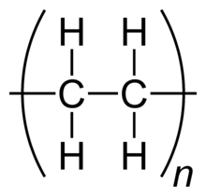 P.V.A 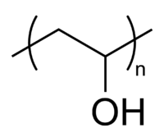

- Explain the experimental results based on the microscopic structure.
- Write five questions that arise after the experiment.
- Formulate research question concerning the experiment, the dependence between two variables.
- Poly-vinyl-alcohol (PVA) is used as collection Bags of dirty laundry in hospitals. They place the bag containing dirty laundry into the washing machine. How do you explain this use?

Activity number (4): Making a decision using a thinking tool.
Dimensions | criterions | Alternative a  Banning the production | Alternative b  Taxes on productions | Alternative c  Increasing the recycling | Alternative d  Reducing the usage | Alternative e  ?
environment | green areas  less waste sites | gain
livelihood | Number of mills  Number of workers | loss
Well-being | Presence of disposable kitchen utensils on market  Low prices | loss
health
?
?

Fill in the missing places: gain / loss. You may add alternatives, dimensions and criterions.
Which alternative way you prefer to choose in order to reduce the plastic waste.

Activity number (5): Presentations
- Display the text which you have received.
- Introduce the thinking tools that you have received.
- Present the way in which your group came to the decision about ......
- Explain how the thinking tools helped you make the decision.

Assessment:
The assessment of the students will be based on the following criteria.
Decision making: ach student will receive only one decision tool, so that he / she will be able to answer only two section of the assessment and the third would be irrelevant .

Scoring | Percent | Criteria | Dimension
 | 10% | Questions raised by students | Picture interpretation 10%
 | 20% | Answers to the questions | Text reading 20%
 | 10% | Performing an experiment according to the instructions in a clean and tidy way | Experiment 30%
 | 10% | Teamwork
 | 10% | Answers to the question / questions( Micro, Macro, Symbol)
 | 10% | Number of alternatives offered to resolve a problem | Decisionmaking 20%
 | 10% | Number of dimensions and criteria taken into account
 | 10% | Range of effects taken into account
 | 10% | Participation of all team members roles in the presentation | Presentation 20%
 | 10% | Articulating on the decision

Acknowledgement:
The idea for the experiment of this module was taken from the Teaching-Learning Materials Tool compiled by the PARSEL Consortium (namly by Streller, Benedict, & Bolte, 2007) as part of the EC FP6 funded PARSEL Project (SAS6-CT-2006-042922-PARSEL) and adapted by the FUB-PROFILES Working Group – Member of the PROFILES Consortium. For further information see: www.parsel.eu.

