Assignment 1: Genetic Counseling

Genetic counseling - why?
This pedigree was drawn up by a genetic counselor following the request of a particular family. The family members were born with their hearing, but some of them suffered hearing loss by the age of 30, and by the age of 40 had become deaf. The family members who contacted the counselor wanted to know whether they are at risk of going deaf. The pedigree tracks the property of adulthood hearing loss. For the sake of simplicity, we will assume that the deafness is a result, in this case, of a specific mutation in a single gene. We also assume that the mutation is rare, i.e. its frequency in the population is very low.

The assignment
We are in a genetic counseling clinic, and you are the genetic counselors. Look at the pedigree below and answer the following questions:
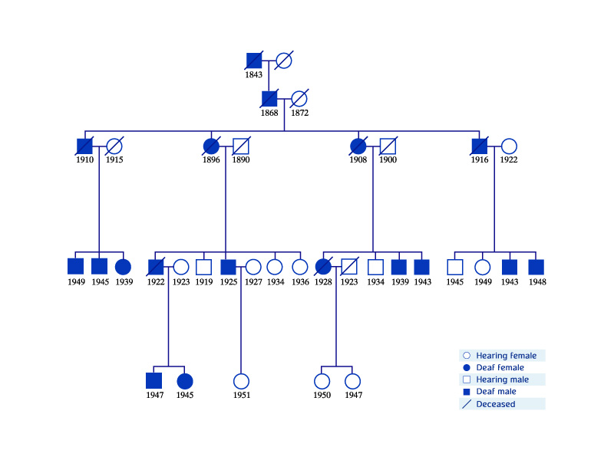

Outline Description
Pedigree of a family
First generation description: Deaf male born in 1843 married to a hearing female. They have one offspring – deaf male born in 1868.
Second generation description: Deaf male born in 1868 married to a hearing female. They have four offspring – two males and two females.
Third generation description:
- A deaf male is married to a hearing female. They have three deaf offspring – two males and one female.
- A deaf female is married to a hearing male. The have five offspring – two deaf males (born in 1922 and 1925), one hearing male (born in 1919) and two hearing females (born in 1934 and 1936).
- A deaf female is married to a hearing male. They have four offspring – one deaf female (born in 1928), two deaf males (born in 1939 and 1943) and one hearing male (born in 1934).
- A deaf male is married to a hearing female. They have four offspring – two deaf males (born in 1943 and 1948), one hearing male (born in 1945) and one hearing female (born in 1949).
Fourth and fifth generation description:
- Deaf male born in 1922 (from third generation) was married to a hearing female. They have two offspring – a deaf male (born in 1947) and a deaf female (born in 1945).
- Deaf male born in 1925 (from third generation) is married to a hearing female. They have one offspring – a hearing female (born in 1951).
- Deaf female born in 1928 (from third generation) was married to a hearing male. They have two offspring: two hearing females (born in 1947 and 1950).

Questions
- What do you think is the most probable inheritance pattern for the deafness allele in this family?
  - Autosomal dominant allele
  - Autosomal recessive allele
  - X-linked allele
  - Y-linked allele
- Are deaf members of this family homozygotes or heterozygotes for the deafness gene?
  - Homozygotes
  - Heterozygotes
- What are the chances of a deaf family member having offspring who will be deaf in adulthood?
  - 25%
  - 50%
  - 30%
  - 100%
- Why do you think is it important to gather as much data as possible on deaf and hearing family members over five generations?
Why aren't most offspring of the fifth and sixth generation displayed on the diagram?
- The answer to question 1 gives the genotype of the adult family members for the characteristics under discussion. Can the genotype be determined for younger family members? Explain.

Answers
- A. Autosomal dominant allele (The phenotype of the carrier of such an allele is usually similar to the phenotype of at least one of his/her parents).
- B. Heterozygotes
- B. 50%

Why the other answers are not correct
- Autosomal recessive allele – is not correct: The phenotype of the carrier of two such alleles is relatively rare, and does not always appear in all generations
X-linked allele – is not correct: The phenotype of the carrier of such an allele is frequent in males, whereas females are carriers.
Y-linked allele – is not correct: This allele appears in males only.
- Homozygotes – is not correct: The allele is rare and autosomal dominant
- 25% - is not correct: A family member will be deaf in adulthood only if he has a single copy of the deafness allele.
30% - is not correct: A family member will be deaf in adulthood only if he has a single copy of the deafness allele.
100% - is not correct:

What have you learned from this assignment?
A genetic counselor characterizes an inheritance pattern by tracking a phenotype. In this example, you established that the most probable inheritance pattern was autosomal dominant. This leads to the conclusion that hearing adults carry two normal alleles for the gene involved in hearing, whereas deaf adults have a mutation in one of the two alleles (assuming that the mutated allele is rare in the population).
The characteristic under discussion is unique in that it becomes evident at a relatively advanced age, and therefore one cannot determine which of the young offspring will become deaf in adulthood. One can, however, determine that all offspring of a deaf parent have a 50% chance of carrying the mutated allele. To decide which of the young members are carrying the mutated allele, their genes must be examined by molecular testing.

