Portfolio
The portfolio is evidence to the professional development of a teacher (O.W.) . The portfolio includes different tasks that teachers had to present/design/write at different stages of the CPD workshop.
- About myself- Description of the teacher.
- About my class - Description of the school and class.
- The module (all parts)
- Reflection after the implementation
- Reflection at the end of the CPD workshop.
- Presentation – dissemination of the module in the 3rd round of PROFILES CPD workshop.
- Evaluation.

About myself
My name is Orit Weitzman. I graduated with a PhD in Chemistry a few years ago from Bar Ilan University. Because I love the profession, I decided to become a Chemistry teacher and gained a certificate in education at Bet Berl college. Since then, three years ago, I have been a high school teacher at "Ehad Haam High School" in Petah Tikva . I am a homeroom teacher and teach Chemistry 10th and 11th grade students.
My goal as a teacher is to engage students in chemistry by relating as much as possible to everyday life in an experiential way.
I attend workshops to continue my professional development. In addition to PROFILES' workshop I attended a workshop on Inquiry Based Science Education for novice teachers in order to teach the lab unit, both were very interesting. I continue to be paid at any time.
About my class
In my school, there are six 10th grade classes (out of nine) who study chemistry and who can choose to major on Chemistry on 11th and 12th grade. Two classes have a population of gifted students; the other four "normal" classes are divided by the average marks of the students in junior high school.
I implemented the module "Ouch! Youch!!" at the end of the school year (2013) in a one of the tenth grade "normal" classes populated by capable students. Throughout the year students were partly engaged in class so I decided to implement the module in order to improve their attitude toward chemistry. I wanted to glorify chemistry prior to the final selection of the major studies in 11th grade.
The module focuses on decision making related to painkillers. At first, students complained about the "task" and about the amount of work expected from them. However, after I insisted, and the module began, the collaboration was maximal. I planned that all the work was done during class; I didn't want to create pressure, I wanted them to like the module.

The module
PROFILES IBSE Teaching/Learning Materials – Overview
Compiled by the PROFILES Working Group of the Weizmann Institute of Science, Israel

Ouch! Youch!!
A Module for Science Instruction – especially Chemistry – for Grade 10

Leaders: Avi Hofstein and Rachel Mamlok-Naaman
Developed by: Orit Weitzman, Maris Notkin, Ayelet Shvalb
Edited by: Dr. Dvora Katchevich and Dr. Malka Yayon
Institution: Science Teaching Department, the Weizmann Institute of Science – Israel
Homepage: http://stwww.weizmann.ac.il/g-chem/profiles/

Abstract

Pain-relief pills are all over!. And there are various types of pain relievers available on the market. How should we choose the best painkiller for us? The module exposes students to different pills and advertisements. Students learn about consumption habits by conducting a survey and about properties of pills by comparing data regarding the pills and interviewing a professional. All these activities help students to make wise decisions regarding choosing the suitable pill.
Subject: Science and/or Chemistry
Grade level: 10th grade
Science concepts: Active ingredient, pill components.
Kind of activity: Internet enquiry, constructing a survey and an interview, group activities etc.
Number of lessons: 4-5 lessons of 45 minutes
Learning outcomes/competences:
• The objective of the Field of Content:
1. Scientific Skills in the World of Medicine
2. Recognition of the Chemical Facets behind the Drugs

• The objective of the Field of Proficiency:
1. Finding the correct information (and not superfluous) from science references
.2. Preparation of a consumer survey (writing suitable questionnaires and editing the replies) asking questions.
.3. Preparing an interview for a professional
.4. The skill of comparison
.5. Drawing conclusions and conducting a discussion
.6. Critical thinking when selecting a drug.

Technical concepts studied in the module
.1. Basic drug concepts
.2. The difference between the shape of the various drugs (tablet, gel)
.3. The difference between the various forms of taking drugs (syrup, suppository)

Attached files
.1. | Student activities | Literary Review  Consumer Survey  Interview with an Expert  Conclusion and Decision-Making  Personal Reflection
.2. | Teaching guide | The scenario will trigger a class discussion about the pain relievers and their consumption.  This module facilitates student learning about:  .1. Scientific Skills on the subject of Medicine  .2. A discussion and comparison between the existing drugs in the market  .3. What is the significance of the active substance in a drug?. What is a generic drug?  .4. The various ways of taking drugs and the differences between them.  .5. The power of advertising for good or bad.

PROFILES IBSE Teaching/Learning Materials – Overview
Compiled by the PROFILES Working Group of the Weizmann Institute of Science, Israel

Ouch! Youch!!
A Module for Science Instruction – especially Chemistry – for Grade 10

Leaders: Avi Hofstein and Rachel Mamlok-Naaman
Developed by: Orit Weitzman, Maris Notkin, Ayelet Shvalb
Edited by: Dr. Dvora Katchevich and Dr. Malka Yayon
Institution: Science Teaching Department, the Weizmann Institute of Science – Israel
Homepage: http://stwww.weizmann.ac.il/g-chem/profiles/

Student Activities
A case Story (Introduction):
A short introductory film, a film that includes advertisements for headache relief drugs We recommend projecting films that advertise drugs that are familiar to the students.(
http://www.youtube.com/watch?v=Bq8CB0cQMTo&feature=youtu.be

Activity 1:
Watch the movie in front you. What questions do you have after viewing?

Discussion
Conduct a discussion in your group and document the following points:
- Which analgesics do you usually use?
- What are the reasons, in your opinion, that guide users when using a particular analgesic?
- What, in your opinion, is the most effective analgesic?
- Out of the three movies that you viewed, what are the considerations and criteria for selecting an analgesic according to advertising agencies?
- What methods are you familiar with for taking the drug? What, in your opinion is preferable?

Activity 2:
Literary Review
Lookup information on the various drugs with which you are familiar in the literature and/or online.
The pamphlets accompanying the drugs should also be read
1. Briefly summarize the following concepts: Active substance, generic drug, capsule (pill), gel, suppository, injection, syrup
2. Select 4 different analgesics. Prepare a comparison in an appropriate table pursuant to the criteria summarized in the class discussion.
3. What does the comparison teach us?
4. Some of the drugs have the same active substance, but, nevertheless, they are given different names. Try to trace the source of the difference
5. Each drug has additional ingredients. Tryto determine their function?
Activity 3:
Group Activity - Consumer Survey.
- Suggest questions for a survey aimed at receiving information about selecting an analgesic and the reasons for its selection.
- This survey should be conducted with at least 30 people. Care should be taken to characterize the population group that interests you).
- Coordinate the survey data and analyze them.
- Present the survey results in a table and graph

Activity 4:
Interview with Experts
Each group must select two experts: One from the medical field (a pharmacist, physician, nurse...), the second from the drug marketing field.
- Preceding the interview, each group of students must sit down and decide who the interviewees are that it has selected and designate suitable questionnaires for them. The number of questions must be defined: 10 questions organized in a logical sequence. On completion of the action, each group must submit the questionnaire to the mentoring teacher for perusal and, if necessary, corrections.
- Simulation: With the assistance of the teacher, simulation of the interview process must be organized in class. During the simulation important emphases must be made such as determining an interview time in advance and the manner of recording and collecting data etc.
Activity 5: (Decision-making):
- Compare the criteria used when selecting an analgesic and the criteria that guide a physician when recommending an analgesic and the criteria that guide marketers. What does this comparison teach you?
- Would you change the drug is that you chose in the initial discussion. Rationalize your answer individually
Invent a new analgesic and invent a new name through which an attempt will be made to market the drug (advertisement or any other marketing idea).

PROFILES IBSE Teaching/Learning Materials – Overview
Compiled by the PROFILES Working Group of the Weizmann Institute of Science, Israel

Ouch! Youch!!
A Module for Science Instruction – especially Chemistry – for Grade 10

Leaders: Avi Hofstein and Rachel Mamlok-Naaman
Developed by: Orit Weitzman, Maris Notkin, Ayelet Shvalb
Edited by: Dr. Dvora Katchevich and Dr. Malka Yayon
Institution: Science Teaching Department, the Weizmann Institute of Science – Israel
Homepage: http://stwww.weizmann.ac.il/g-chem/profiles/

The Products that are Attached According to Lessons:
The sequence of the described activities leads the students to intelligent selection on the subject of "analgesic for headaches"
On completion of the first activity pupils will be expectedto understand that there are many drugs for the same disease. They should understand that here too there is an advertising market.
On the conclusion of the second activity students are expected to successfully summarize the concept expected of them – Understand how the literary material is summarized (without copying). Students must understand how to make an efficient comparison, the proper selection of criteria and proper recording of a table
On completion of the third activity students are expectedיto know what a survey is, that there is significance to the community reviewed, who this community is (the diversification), understand that the community must be selected according to the desired results in the survey. The students must be able to compose diversified questions organized for the survey, to organize and arrange the results of the survey in a table/chart form.
On completion of the fourth activity students are expectedto be familiar with interview skills. Students must know how to make. a correct and rational choice of the interviewee's identity. Students must know the proper and organized method of preparing an interview.
On completion of the fifth activity students are expected to understand the significance of intelligent choice. Knowledge for rationalizing their choice effectively. They will know how to summarize their work and how to record their true deductions from the project.

Recommendations for Teaching Strategy
Activity 1:
After viewing short films, a class discussion must be held in the classroom according to the questions raised by the students.
Important points should be written on the board.
For example, in our class a discussion was held on the significance of advertising when reference is to drugs. Can we really decide what drug to purchase (is this like the advertisement for cheese or any other food)? Why are there so many types of drugs for the same disease in any case?
It is important to emphasize for the students that the module facilitates learning how to choose anti-headache analgesics in an intelligent manner.
Activity 2:
Part A: Each group gets homework to prepare one concept from the list and to summarize it briefly. The conclusion must be sent to the student who has volunteered to prepare an informing conclusion document. Students should be asked to bring various boxes of drugs to the next lesson.
Part B: Which criteria for comparison selected by the students must be examined and a discussion should be held on this. It is preferable to examine which criteria for comparison the students chose and to conduct a discussion on this. It is preferable to summarize the issues on the board in a common table.
Special emphasis should be placed on the generic name of a drug, the active ingredient in the drug and the manner of taking it
.Sample for a table
Name of Drug | Price (NIS) | The Active Substance's Name | Active Substance's Formula | The Effective Time (minutes) | Main  Adverse Effects | Manner of Taking the Drug

Activity 3:
Consumer Survey: The student should be guided to compose a diversified questionnaire that outlines the survey objectives. Sample Questions: Which drug do you take? How? Why did you choose this drug? They should be guided to conduct a short and exhaustive survey .The survey should be conducted during recess when there is the control over the number and diversity of people. (Teachers, students, administrative staff etc.).
Following is an example of a summary table:
The Interviewee. | The Preferred Drug | The Active Ingredient | Frequency of Use | The Rationale for the Preference

Remark, the major difficulty facing the students is to arrange the questions logically and abbreviate the interview. They are overwhelmed and prepare numerous questions, and it’s a pity that an undesirable situation in which people do not wish to respond to the survey is created.

Activity 4:
Preceding Activity on how to Conduct an Interview
The purpose of the interview is to examine an array of considerations when selecting an analgesic drug
Emphases for students in the Interview Formulation Process
- What do I want to know? First of all you must understand as precisely as possible what you want to know. Write down everything and arrange the subjects according to a predetermined order (A logical order of questions is difficult for students. You must make sure of being concise, clear and simple
- Selection of the Survey Respondents You must choose two relevant characters for the subject that you wish to survey; one from the medical field and the other from the drug marketing field (a physician/pharmacist/advertiser/marketing individual etc.).
Preparing a Survey Orientated Questionnaire You must determine a subject question for each of the subjects that you predefined, in the wake of which secondary questions will be asked. Define the question in the simplest manner that you can. The questions must be very clear so that no contradictory aside questions can be asked Remember that you want to receive answers
.The number of questions must be defined: 10 questions that must be arranged in a logical sequence. During the initial stagethe students prepare the question sheet for the interview with experts on the web (or transmit to the teacher via the Mashov), while including the teacher online for the purposes of perusal, consultation and, if necessary, corrections.
- After the questionnaires have been prepared, the teacher must conduct a simulation of the interview process in the classroom in order to prepare the students in advance. During the simulation important emphases must be made such as determining an interview time in advance, the manner of recording and collecting data etc.
It is important to begin the interview with a pleasant discussion or question that should create a comfortable atmosphere for the interviewee: "Thank you for consenting to be interviewed"
Following are Examples of Questionnaires:
Questionnaire for a person taking an analgesic
- Do you suffer from pains frequently?
- How many types of analgesics do you know?
- Which analgesics do you take?
- Do you know what the active ingredient in the drug is?
- Do you know what the drug's reaction mechanism is?
- Are you aware of the differences between the various analgesics?
- Do take the same analgesic for all types of pain?
- How did you choose this analgesic?
- Which professional did you consult in order to decide on a feasible analgesic to take? (physician/nurse/pharmacist/no one...)
- Is there a well-known advertisement for the analgesic that you take?
Questionnaire for a Professional
- How many different types of analgesics do you know?
- What are the major differences between the various analgesics?
- How many types of active substances for analgesics do you know?
- Which analgesic would you recommend the most and why?
- have you also used the drug that you recommend for customers?
- Do people ask for a particular drug or do they ask for your recommendation?
- In your opinion, what are the guiding principles for a person taking an analgesic and, in your opinion, what should they actually be?
- Is the price of a drug a consideration in your opinion?
- Are the additional drugs that a person takes important? Why?
- Is the advertisement reliable and can it be trusted when selecting drugs?
A pointer for a Comprehensive Evaluation of the investigative Activities – Ouch and Youch
The Names of the students in the group ___________________________
The Dimension | The Maximum Score | Criteria for Evaluation:  The students… | Evaluation |  | Score
Introductory Activity | 10 points | There is a broad and comprehensive reference to all the parameters, diversification and questions
 |  | A detailed and focused discussion on the subject is conducted
Literary Review | 15 points | Details and explanations for all the relevant concepts
 |  | The results are presented clearly including comparisons, detailed conclusions and deductions.
Consumer Survey | 20 points | Focused questions
 |  | The extent of the survey, quantity and diversity of respondents
 |  | Concentration of data in a table and graph
 |  | Data analysis and deductions
Interview with an Expert | 25 points | A sequential structure of the questionnaire and its relevance for the interview object.
 |  | A focused and organized coordination of the interview data
 |  | A concluding discussion for the interview and deductions (limitations of the interview and validity of the deductions)
Conclusion and decision-making | 15 points | The conclusion presents all the aspects raised in the various sections
 |  | A discussion that relates to decision-making and the appropriate choice must be conducted.
Personal Reflection | 5 points | Reference to the various activities from a personal aspect
Submitting the concluding file | 10 points | All the sections including the activity sheets appear in the correct order.
 |  | The file must be submitted in an organized aesthetic manner and must be written in correct language

General Evaluation
Total points | Final score | Teacher's Signature

A Pointer for the Task Performance Evaluation by the Students
Criteria | A High Performance Level 4-5 points | A Medium Performance Level 2-3 points | A low Performance Level 0-1 point
Introductory activity | There is a broad reference to all the parameters and the diversified questions | Reference to some of the parameters. Questions are not diversified questions or are repeated | The task was performed partially and superficially
 | A detailed and focused discussion must be conducted on the subjects raised | The discussion is partial and does not deal with all the parameters raised | No discussion and there is no reference to the subject raised
Literary Review | There are detailed explanations for all the relevant concepts | Detailed explanations for some of the concepts or only partial explanations. | Only superficial and partial explanations for some of the concepts.
 | The results are presented clearly and fully, including comparisons pursuant to relevant criteria in the table, a detailed conclusion and deductions. | There is no clear conclusion of the results in the table/criteria are lacking / partial deductions | There is no concluding presentation of the results and no deductions have been drawn.
Consumer Survey | Diversified and focused questions | The questions are repeated/are not focused. | No questions were asked
 | The number of interviewees - 20-30 and they are diversified. | The number of interviewees - 10-20 and partial diversification. | There are less than 10 interviewees and they are not diversified
 | The data concentration is clear and organized in a table or graph | The data concentration is partial A table or graph is lacking | There is no clear and organized data concentration
 | A detailed data analysis and detailed deductions | Partial data analysis and general deductions. | Only a superficial analysis of the results
Interview with an Expert | The questionnaire is structured according to a logical sequence and a broad range of questions | The questionnaire lacks a logical sequence and the questions are not diversified/are repeated | The questionnaire is superficial and lacks order
 | The interview data are concentrated in a focused and orderly manner | The interview data are not focused and organized | There is no organized concentration of the interview data
 | There is a detailed discussion that relates to all the interview components, which concludes with intelligent deductions | .The interview conclusion has been discussed superficially and deductions drawn cannot be based on it | No conclusion of the interview has been written or the deductions drawn from it are lacking
Conclusion and Decision-Making | The conclusion presents all the aspects raised in the various sections and connects the perceptions and activities | A partial review of the subject and the aspects that arose throughout the module/there is no connection between the theoretical material and the activities | The written conclusion does not demonstrate significant learning, It does not touch on the perceptions from the activities or present the background studied
 | A discussion that relates to decision-making and a suitable selection is conducted – there is a connection between the perceptions and decision-making | While there is a reference to decision-making, the decision is not fully based on the perceptions obtained from the module | No reference to decision-making appears in the conclusion or there is a reference which is not based on the matter
Personal Reflection | Reference to the various activities from a personal aspect – both for the importance of the subject and the activities | The reference does not present personal aspects/a general reference to the subject without examples | There is no expression of personal thinking about the various activities in the module
Submitting the Concluding File | All the sections including the activity sheets appear in the correct order. | Action sheets are missing/the file is not arranged according to an order that enables a follow-up | Sections are missing, activity sheets are not attached and there is no sequence
 | The file must be submitted in an organized aesthetic manner and must be written using correct language | Language problems – No reference to the aesthetic side is noticeable | The file was not submitted in an aesthetic manner and there are many language errors.

Background material on the subject of the module:
What is a drug?
A drug is a preparation produced by a drug or preparation company that is compounded at a pharmacy by a qualified pharmacist. A drug comprises an active chemical substance (from a natural or synthetic origin), which affects the living cell and changes its activity. The drug contains additional substances for determining the manner and form in which it is administered (tablets, capsules, syrups and suppositories etc.). A drug has proven pharmacological activity, which should benefit the patient. Undesirable activity of a drug is defined as an adverse effect. Marketing a preparation as a drug requires approval from the country's health authorities (in Israel the Pharmaceutical Department of the Ministry of Health; in the United States the American Food and Drug Administration, the FDA.
Dictionary of Terms
A generic drug is a drug produced and marketed when there is no patent registered and valid on its active substances. It can be marketed in countries in which the patent has expired or in countries in which no patent on the original drug was registered. In order for a drug to be recognized as a generic drug to an existing drug, it must contain precisely the same active substance as the original drug and copy the duration of the activity of the original drug in the body. Development of a generic drug is quick and its price is usually cheap. The effect on the human body should be identical to the effect of the original drug.
In most countries throughout the world drug patents are valid for 20 years. However, for the most part they are registered before commencing clinical trials on them, so the lifetime of original drugs prior to the generic versions appear is usually 7 to 12 years. Once the generic versions appear the prices of the original drugs usually drop. There are drug companies that specialize in producing generic drugs The Israeli company, Teva Pharmaceutical Industries is considered to be the largest generic drug producer in the world.
The company that produces the original drug usually has the rights on the original name of the drug. Consequently, the generic drugs are given a different name. On many occasions they are given the name of their active ingredient. The only limitation when determining the commercial name of a generic drug in a particular country is that using a registered name on which the rights have been granted to another drug company is prohibited.

Tablet: The comprehensive term is "tablet," which is a flat "pill" usually for swallowing, "a sucking tablet," which is commonly used for alleviating throat ache, a "chewing tablet" which can only be chewed and lastly "effervescent tablets," when the water which they effervesce is drunk.
Caplet: A caplet is an oblong tablet.
Capsule: A drug made from powder or a fluid and administered inside a gelatin capsule, for example, most of the antibiotics.
Syrup: Certain drugs are taken when they are blended in syrup. Sometimes because the person taking the drug cannot take it in the form of tablets or capsules because of a young age or physiological or psychological problems which prevent him from taking tablets. Sometimes this is the most efficient form of the drug, for example, cough syrup.
Syrup: Certain drugs are taken when they are blended in a syrup. Sometimes because the person taking the drug cannot take it in the form of tablets or capsules because of a young age or physiological or psychological problems which prevent him from taking tablets. Sometimes this is the most efficient form of the drug, for example, cough syrup. The taste of the syrup is usually added to the simple syrup using flavoring agents.
Many drugs are commercially available only in tablet or capsule form, because the drug companies do not have any economic reason to develop them in a syrup. Preparing a syrup of drugs, which do not exist in this administering form commercially, is usually performed at a pharmacy by a pharmacist who is an expert in English. When planning to prepare syrup, the instability of the drug in the liquid syrup, the possibility of floating or dissolving the drug uniformity in the liquid (homogeneous) and the use of preservatives must be tested. In simple instances the medicinal syrup is prepared by adding the drug or dissolving it in simple syrup. In other cases, the acidity of the liquid must be adjusted, wetting agents and floating agents and preservatives must be added.
Suppository - A drug administered inside a solid colloidal preparation, which is adapted to inserting into the anus or vagina in which it is released.

Functional Groups
- A Functional Group
An atom or group of atoms, the existence of which in a molecule hints at belonging to a particular group of substances. The functional group's existence in a compound is responsible for the chemical and physical properties of the compound, for example, such as solubility, boiling point, volatility
Common Functional Groups:
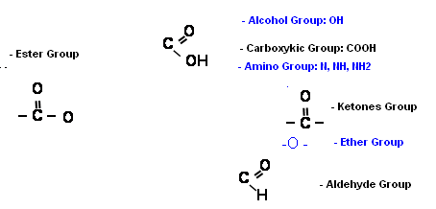

The Active Substance | Generic drugs in Israel | Chemical Structure | Action Mechanism | Adverse Effects and Risks
Paracetamol | Acamol, Dexamol, Abrolet (suppositories), Paramol, Aldolor (concentrated drops  Rokamol and Panadol | 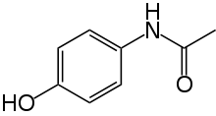 | It is active in suppressing the Cyclooxygenase enzyme, COX, which is, to a large extent, responsible for the perception of a sense of pain in the brain, and suppressing the enzyme results in alleviating the pain.  In cells in which there is a high concentration of hydrogen peroxide, which disrupts the action of Paracetamol on the COX enzyme , the drug has only a minor effect. Consequently, in contrast to aspirin, Paracetamol does not have any anti-inflammatory properties. | Possible damage to the liver, taking more than four tablets per day is prohibited.
Acetylsalicylic Acid | Aspirin | 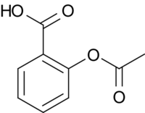 | The aspirin blocks two enzymes. One is called Cox-1, which is responsible for producing the mucus that protects the stomach wall.. The other is called Cox-2 and it regulates a chemical agent called Prostaglandin, which regulates body temperature, a sense of pain and inflammation. Over recent years, it has been discovered that aspirin's protective effect is expressed on two planes: It aids blood dilution, reduces the inflammatory process generated in the blood vessels and which is likely to contribute to their occlusion. | In view of the aspirin's blood thinning activity and preventing coagulation, a hemorrhagic condition could be generated.
Dipyrone | Optalgin | 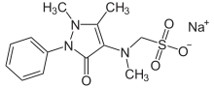 | Its activity mechanism has not been interpreted sufficiently. Inhibiting the synthesis of Prostaglandi in the central nervous system, inhibiting the enzyme, adenylate cyclase which mediates in pain, Direct blocking of the calcium ion is possible.. | This drug has the rare and dangerous adverse effect of Agranulocytosis. Because of the risk, since the -1970s the use of Dipyrone has been prohibited in the United States, and , at a later stage, in other countries..
Ibuprofen | Advil, Neuropen, Adex |  | Ibuprofen is actively similar to aspirin .  Ibuprofen acts by suppressing the activity of the COX enzyme family. The enzyme develops synthesis of Prostaglandin, the main pain and inflammation agents. There are at least two strains of Cox, Cox 1 and Cox 2 Ibuprofen inhibits both of them in a similar manner. The desirable activity of an analgesic, lowering fever and reducing inflammation is mediated by Cox 2, while suppressing Cox 1 - Responsible for the undesirable effect of damage to the digestive system and the general undesirable effect of damage to the action of the platelets. | Hemorrhaging in the digestive system after prolonged use

Reflection Questionnaire after implementation in Class
Class Description:
- The activity was performed in Class ___10______
- The number of students in the class _____37_______
- Number of boys ___17____ number of
girls _______20__
- Is this a chemistry stream class/according to a stream selection? Before
- Describe the class according to its capabilities ___ Reference is to a relatively good heterogeneous class. Half of the students selected a stream ___________
- Is the class homogeneous/heterogeneous? From which aspect? (Interest, capability, motivation) heterogeneous. From both capability and interest aspects. Some of them are not realistic and have no interest in chemistry.
- Describe your school (municipal, of settlements, private, selective etc.)____A Reali High school. The pedagogic issue is highly reinforced The matriculation ratio is very high. Estimated excellence ________________________________________________________

Reflections on Teaching the Module
- Reflections on the Three Sections of the Student Activity
- How was the subject presented in class? The subject was presented in class as a bonus. The goal is to generate interest, to provide space for something new and exceptional and link chemistry to routine daily life. This is also an opportunity to improve grades as they have been promised that the grade will form a sizable percentage of the grade in the report card. ________________________________________________________
- How did the students respond to the presentation of the subject? __ Most of the class (girls) were truly excited and happy. There is a consolidated group of basketball players, who expressed their objection angrily and loudly. They even argued that they preferred a test and not having to deal with this "junk." They actually begged.... (: _________________________________________________________
- Do you think that the introductory scenario interested the students? Yes/No
- Do you think that the introductory scenario was relevant to the students? Yes/No
- Would you have changed the introductory (scenario)? Yes/No . If positive, how would you have changed it? __ Regarding the introduction: Our introduction was very captivating and funny. We showed advertisements for drugs and the students really enjoyed them. They screened them over and over. Obviously the hit came when I showed them the movies on their cellular phones using a barcode . The students even added to this and found more advertisements, which they showed me
(: ________________________________________________________________
- Did the activity during the survey stage interest the students? Yes/No
- Was the activity during the survey stage relevant to the students? Yes/No
- Would you make any changes to the survey stage in the module? Yes/No . If positive, how would you have changed it? ______________There was no survey in our module.
- Was the activity in the decision-making stage successful? Yes/No
- Did the activity in the decision-making stage result in students taking an active part Yes/No
- Would you make any changes to the decision-making stage? Yes/No. If positive, how would you have changed it? ________ Regretfully, despite the fact that this was the more important part of the module, because I performed it at the end of the year, I could not dedicate sufficient time to you and that's a pity. I noticed that here the students had much difficulty. They were also disappointed that they did not have enough time to discuss their results, as this interested them very much. ____________________________________________________________
- Did the student evaluation during the various stages reflect their work? Yes/No
- Would you change the evaluation? Yes/No If positive, how would you have changed it? __________________I believe we gave a good evaluation _____________________________________________________________
- Did the students expand their knowledge in the content field as a result of the module activity? Yes/No.
What evidence can you provide that backs your replies?
Throughout the module activity, the students did not stop relating to and reporting (to me and amongst themselves) what they had learned from that activity. They were amazed by the replies received from professionals, by the lack of knowledge of people that they discovered during the survey, by the quantity of drugs in the market and by the manner of decision-making amongst laymen and professionals. They also learned much about the ways of taking the drugs and the way they have an effect __________________________________________________________
Were the instructions given to the students clear to them? Yes/No If negative, how would you have changed it? ___
- Was the time that you dedicated to the activities appropriate? Yes/No If negative, how would you have changed it? _____________ As aforementioned, I was not able to dedicate sufficient time to each task. Many hours were wasted and the mathematics matriculation examination was in the middle, which upset the continuity.
- in my opinion, the one good aspect was that all the activities were performed in class (apart from the survey and interviews) and I was able to rotate amongst the students and guide each group according to what they found to be difficult. This was highly effective.____________________________________________________

- Reflections on Activating the Module
- Did the students work in groups? Yes/No
- Did the module include sections for the students' independent work? Yes/No
- Was there any discussion in the class plenum while activating the module? Yes/No
- Would you make changes to the volume of the parts mentioned in Sections 1-3 Yes/No
If positive, how would you have changed it?
_______________I chose to dedicate much time to discussions, which came at the expense of group work. I have not yet decided on what is preferable and I will have to give this some thought in the future. _________________________________________________
- Did any difficulties arise during activation? Yes/No If positive, how would you describe the difficulties?
- How do you propose to overcome the difficulties that arose?
Only regarding the times, perhaps it would be preferable to activate the module during a less pressurized period than that in which many hours are wasted.

General Reflection
- Do you think that the module served the project's objective:"Educating through Science"? Yes/No If positive, explain how.
Absolutely!!!
- Do you think that the module served the project's objective: "Teaching through Science"? Yes/No If positive, explain how.
In my opinion, this module was a different type of survey.. It did not include a trial survey, but did include a literary and social survey. In my opinion, performing the survey contributed much to the students and I find it difficult to think of any other opportunity in which they would be occupied in this kind of survey.
Do you think that the module served the project's objective: "The Student is at the Core"? Yes/No. If positive, explain how
In class, the students determined the rate, they chose whom and how to interview, they chose on what to place an emphasis in their work and, in truth, there were no 2 identical projects. ____________________________________________________________
- Are you considering activating the module again? Yes/No. Explain why.
____it is obvious to me that I will activate a module again next year, but in truth, I do not know which. Because of both the discussion and the reasons that I will detail below. Are you thinking about recommending other teachers to activate the module? Yes/No. Explain why.
Unequivocally!!!
Try to explain your reply regarding the module that you developed.
The truth is that, initially, throughout a lengthy part of the year (Dvora knows) I was rather disappointed by the module. It did not seem to be sufficiently "scientific" to me and I really wanted a trial study However!!! And at this point there is a huge "but," after I commenced distributing the module in class, I noticed how much they were enjoying it and how much they indeed learned (simply different skills...) I was most enthusiastic. I discovered that other skills (survey, interviews) are important and contribute much to the students. Furthermore, there was an "echo" throughout the school. Because of the survey, which even included the administrative staff, everyone heard about the project and, now, other classes also want it. The contribution to the students, as well as to me as a teacher, was simply amazing. Do you think that completing the questionnaire assisted you in getting insight into activating the module? Yes/No. If positive, explain how.
It honed various emphases, such as the student at the core for me. I'm not sure that I would have thought about this as such.

With G-d's Grace 24.6.13
General Reflection
By: Orit Weizmann
Okay, so let's begin at the beginning. I came to the enrichment course because I was interest in innovation for the students and myself (I am easily bored...). Furthermore, I have always been interested in the subject of integrating chemistry into life.
The beginning was quite weak as I did not really find my place in the correct group (Limor left) and some time elapsed until I understood what you are looking for and how everything would ultimately appear.
The idea of reflection came to me out of a totally personal interest. For many years, I have been suffering from migraines and the subject of analgesics has always bothered me. I always thought that this was the be all and end all. However, I very quickly understood (quite by mistake) that the subject wasn't "anything special," as there is no chance of conducting a trial survey here. Then I also thought that this was the whole point :).
This was quite depressing for me throughout the course and, as you know, I did not conceal this. However, we continued. Ayelet was the main driving force and better so. We always complemented each other. Only after I had activated the module in class did I understand what we had created and what a sound activity we have in our possession. If this was another trial survey, we might have attracted another one or two students, but here we attracted all of them. The students were truly enthusiastic about performing the survey and interview. There was true warfare at the school as to who would be the first to interview and how many, and who would participate in the survey (the more accepted). and who wouldn't. Even the administrative staff cooperated. I received echoes form all over!!!
Of course, the students learned a lot from this. From critical thinking they learned which questions were beneficial and which were less, whom, at all to interview, how to present the results (what is a pie graph??) etcetera
Indubitably there are life skills here.
In short, this is the stage in which I began to enjoy myself. This is also the stage in which my students learned that their colleagues in the second high school (of Ayelet) were conducting the same project and wow, the excitement! What competition!!! (:
That's it, I had done my bit. As far as I am concerned, the success began right here. From that moment (the survey) most of them cooperated fully. It really began to appear to them as a bonus and, I think that already the grade was of less importance. They were truly enjoying themselves (apart from a small group of guys, who made sure to emphasize that they still preferred regular tests all the time). However, the fact that there is never 100% cooperation is logical and this was clear beforehand.
In conclusion, I can only emphasize that, to my regret, I did not have sufficient time for the module. The matter of the concluding discussion was too short and they also stated this in the reflections they wrote about the tasks. They wanted a little more discussion on the manner of intelligent and correct decision-making. What a pity that once again, mathematics interrupted us here and took lessons then...
Regarding the students themselves, the brief interviews that I conducted during recesses (again because of the shortness of time) indicated that most of them enjoyed themselves and even learned much here. They were happy about the diversification in learning and the manner in which the lessons were conducted. They also enjoyed independent and group learning. They also said that they had found it interesting and important to study things that, in the norm of things, they would not have studied now, such as Excel, conducting surveys and the interviews.
- In conclusion:
  - A number of new and interesting skills were learned here.
  - Some students interviewed their relatives and returned with sound insights. One girl student said that this was the first time that she had interviewed her mother (a nurse by profession)
  - Indubitably, while I did not manage all the material in class in preparation for the stream, we ended the year differently and specially and this was good.
  - I think that the module is still a little problematical as the chemical knowledge here is not suitable for the 10th grade.
This was an interesting and different enrichment course. When, ultimately the question as to who gained more here, the students or I is asked, I have no answer!
Dvora and Malka,
Thank you for an interesting year, for the innovations during the lectures, the support, your persistent desire to innovate and challenge us and, primarily, for the fact that, from the outset, you believed in the module!!
Orit Weizmann

Presentation – dissemination of the module in the 3rd round of PROFILES CPD workshop 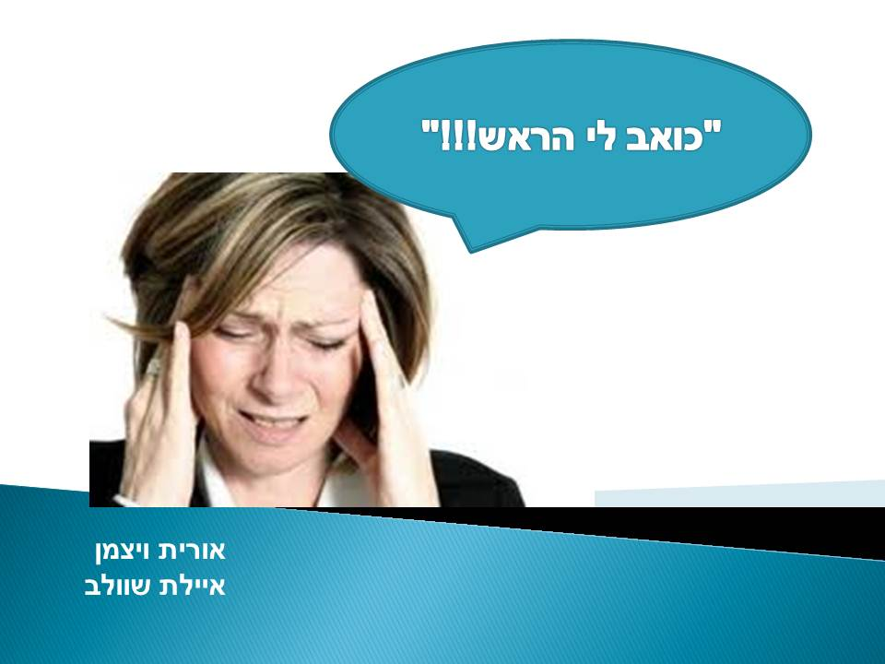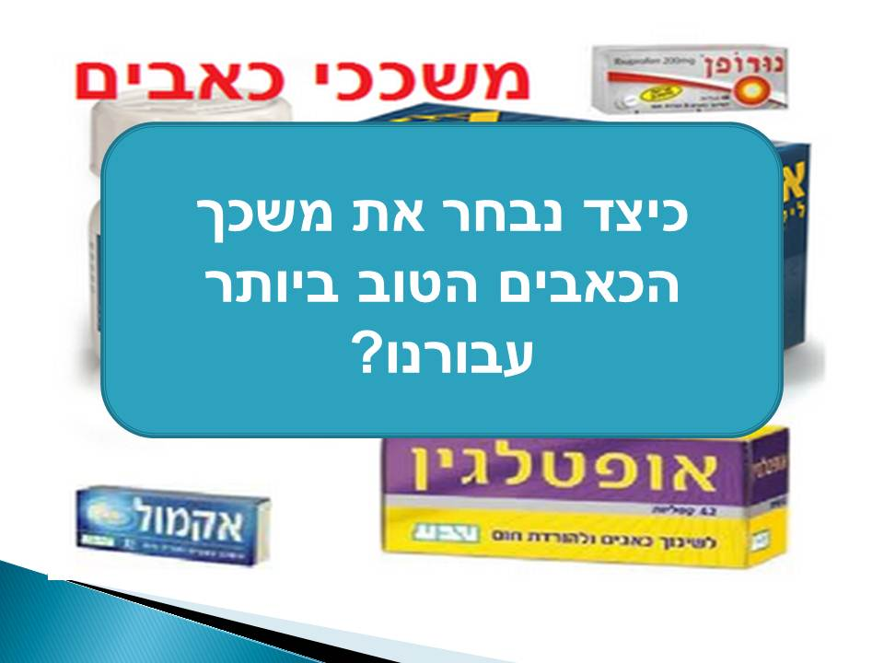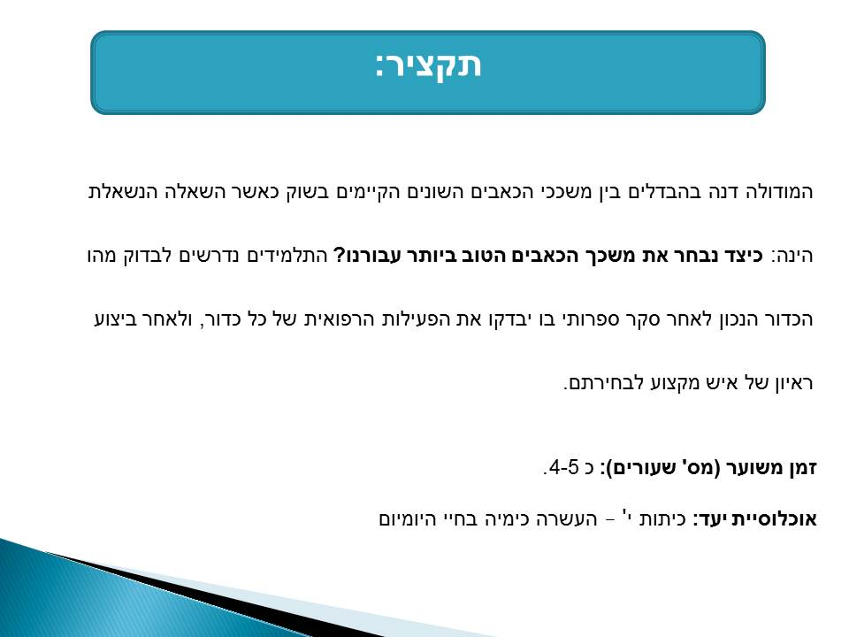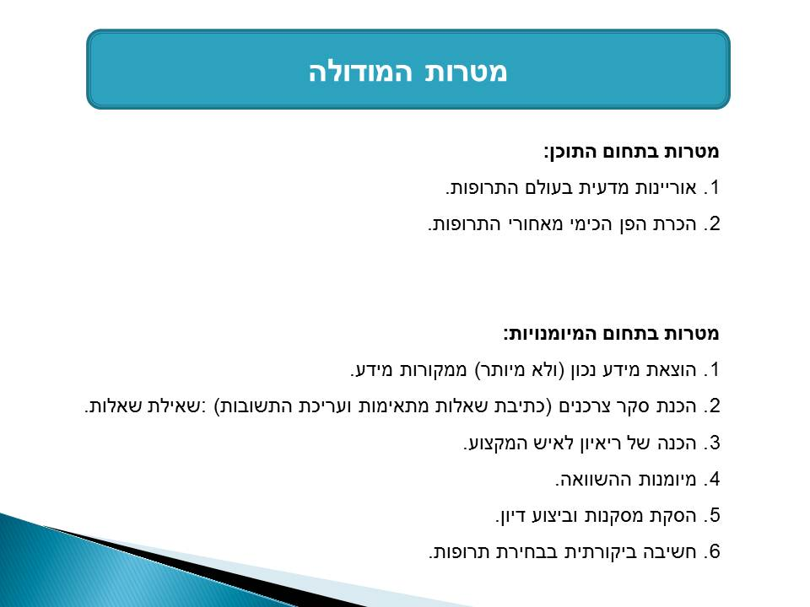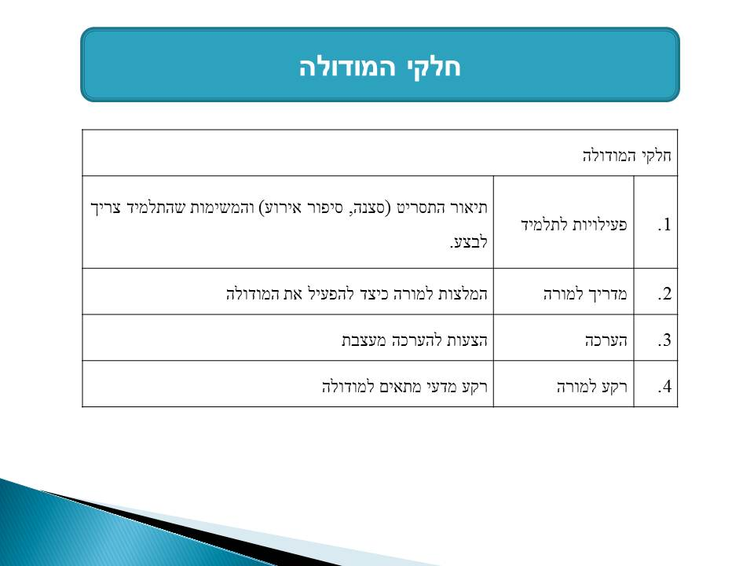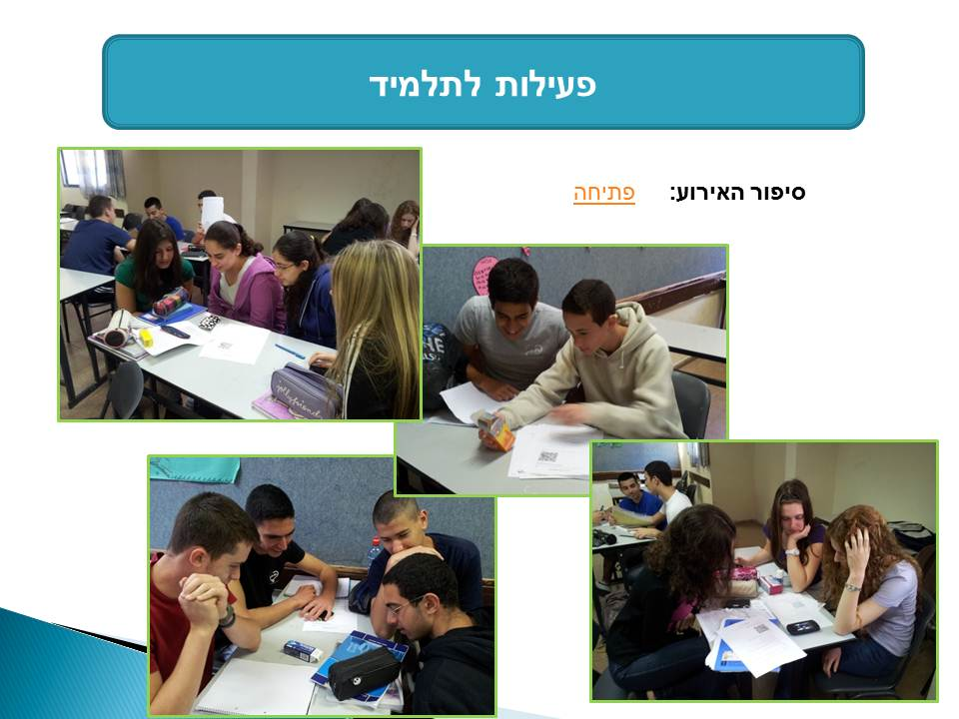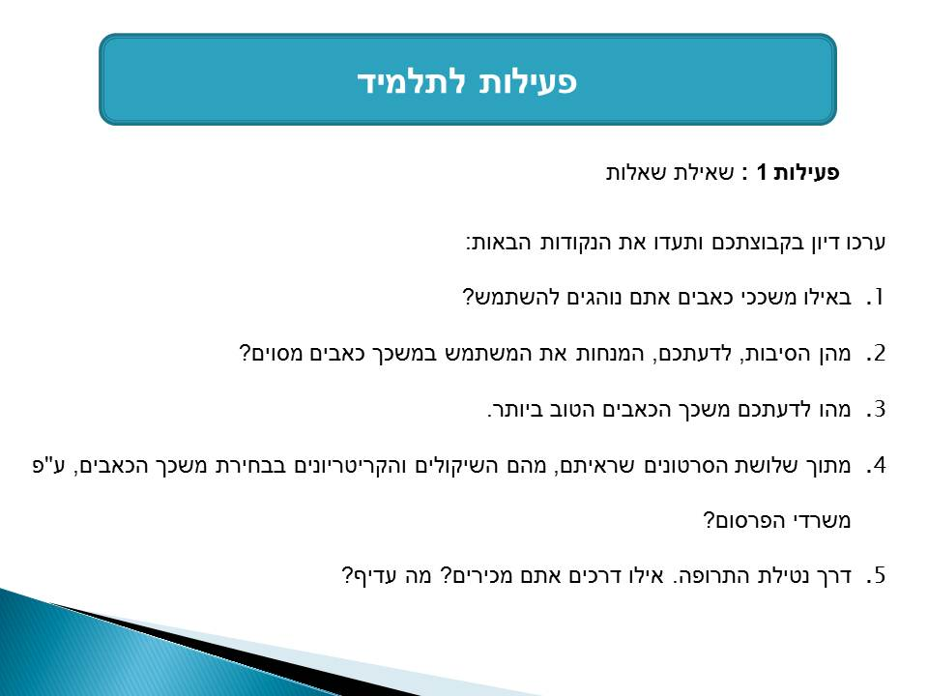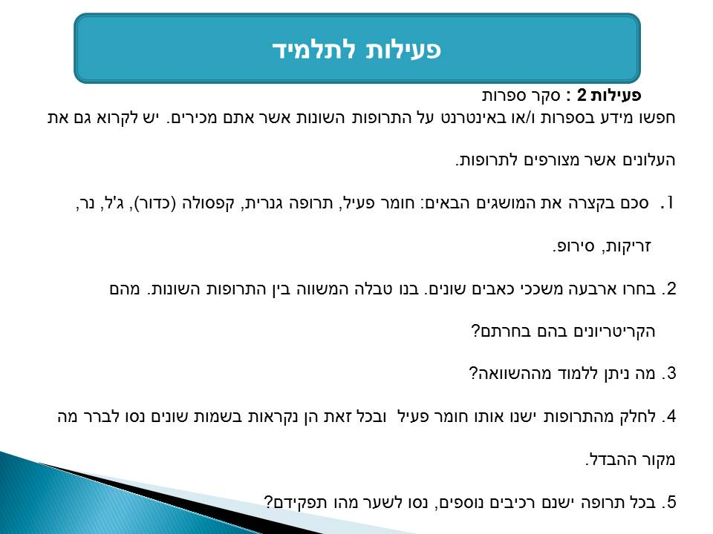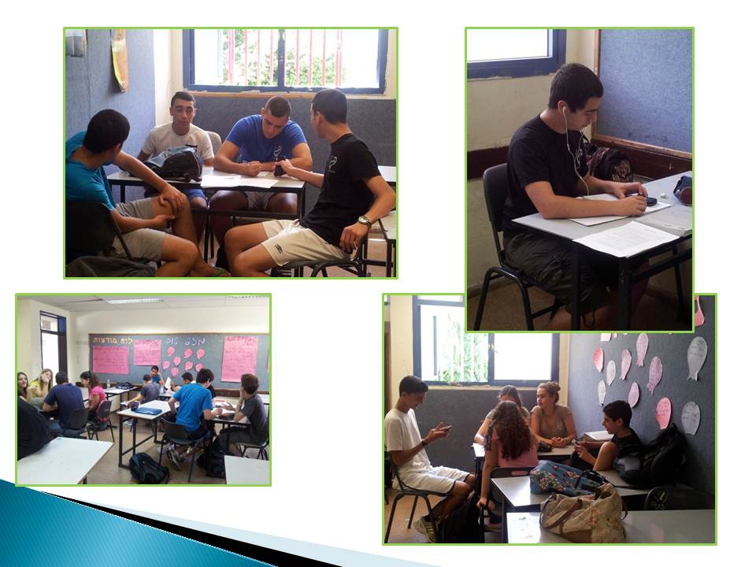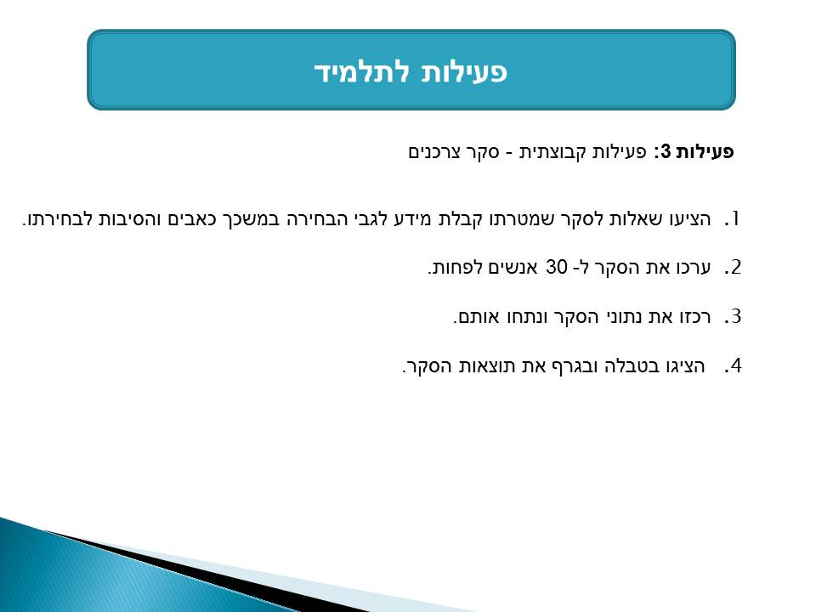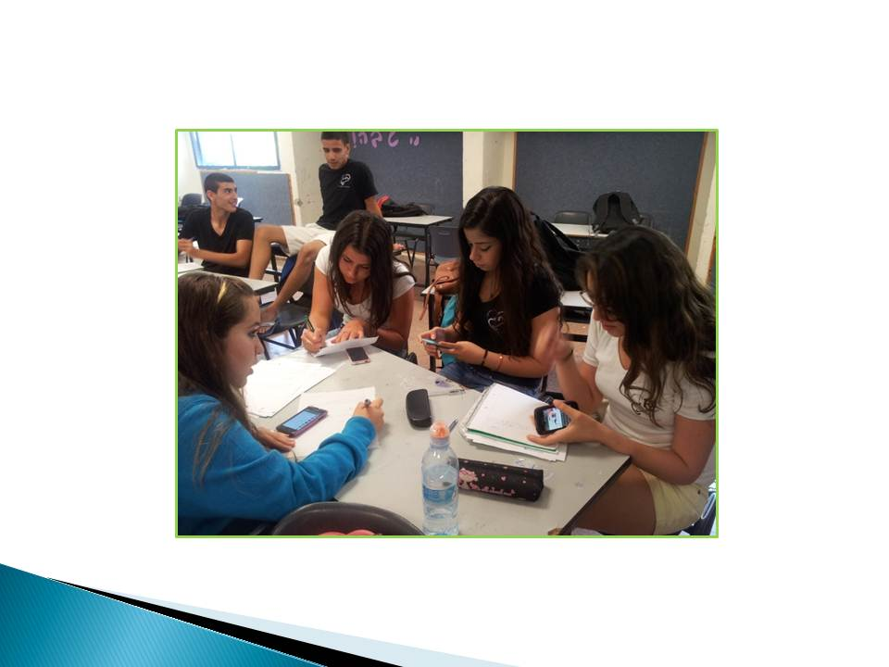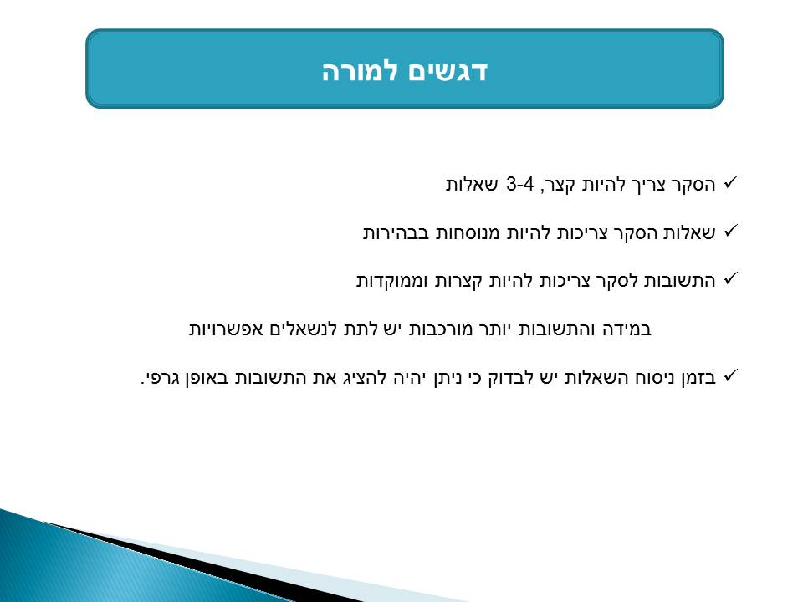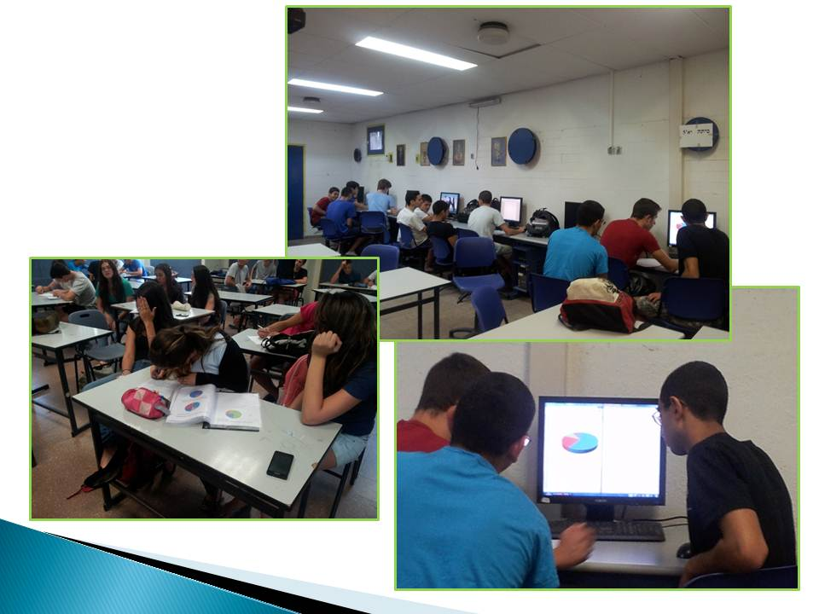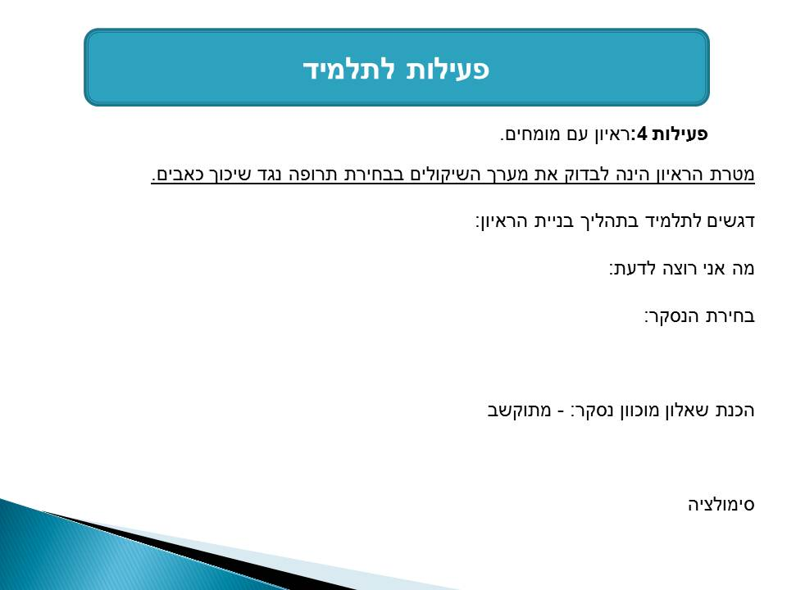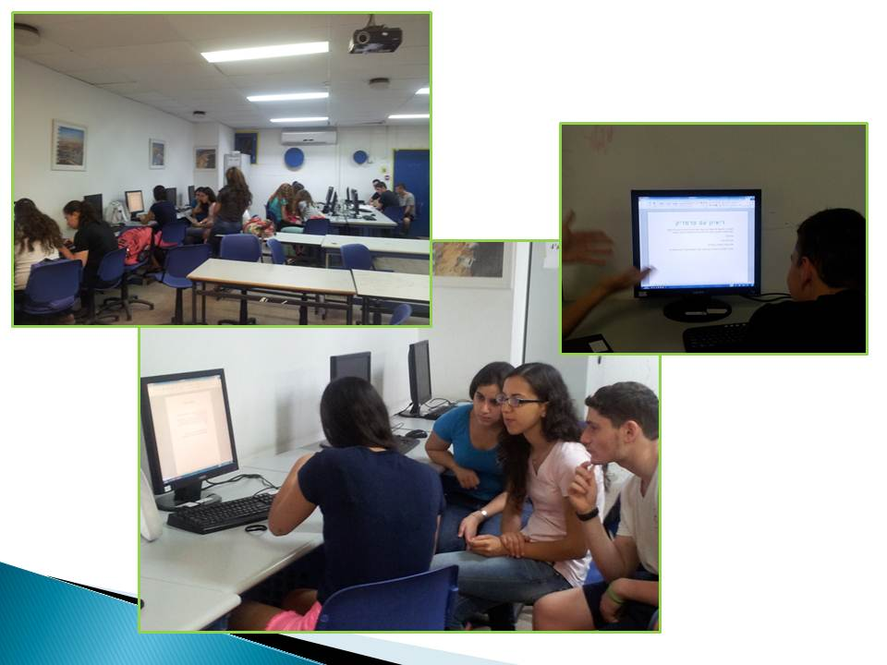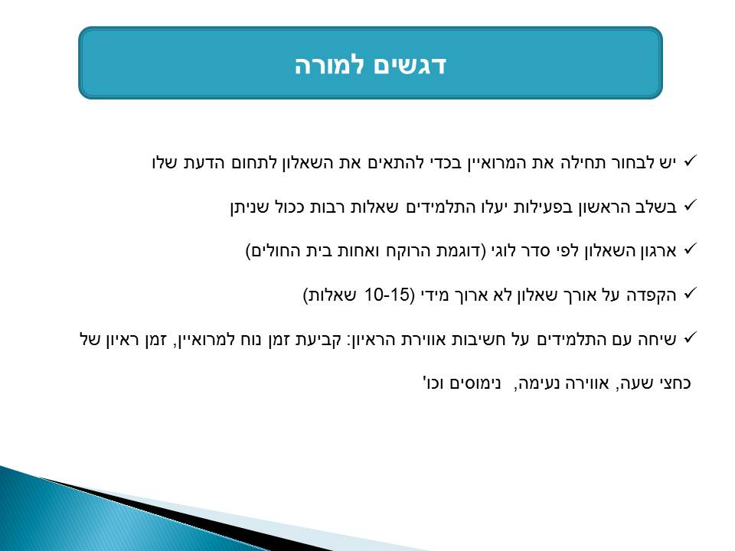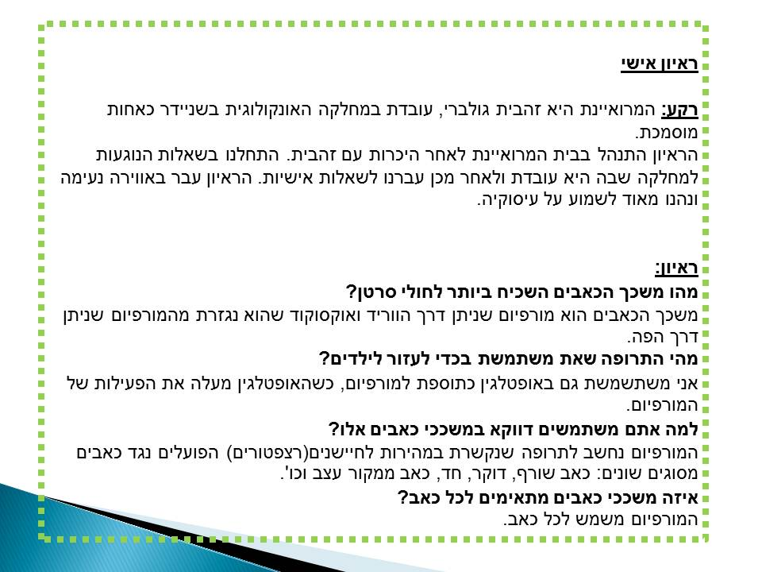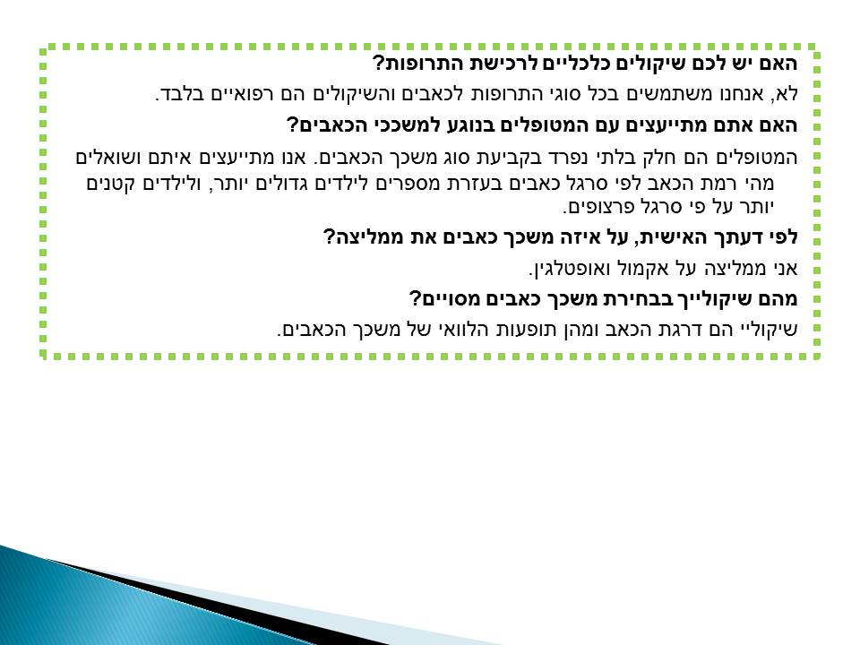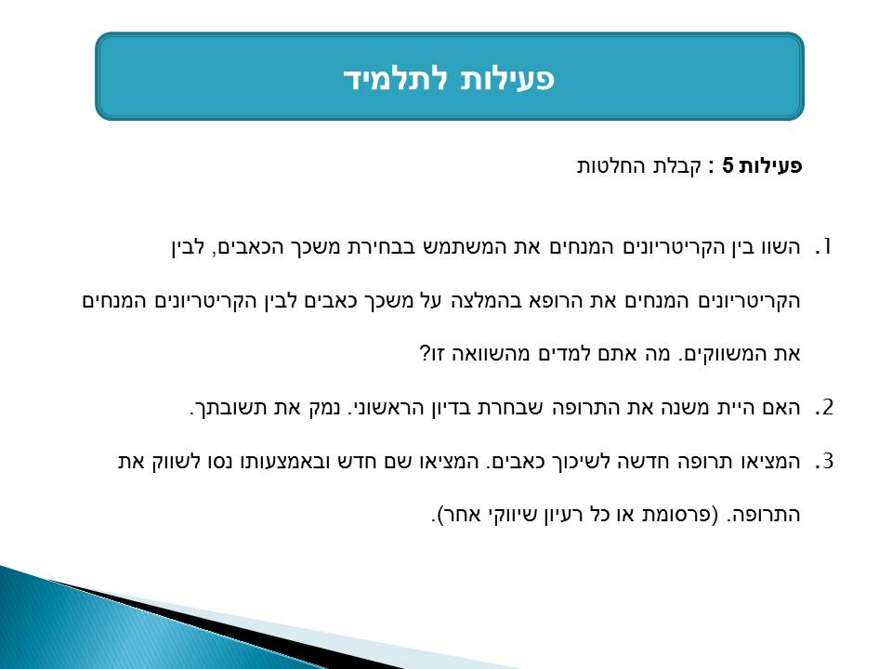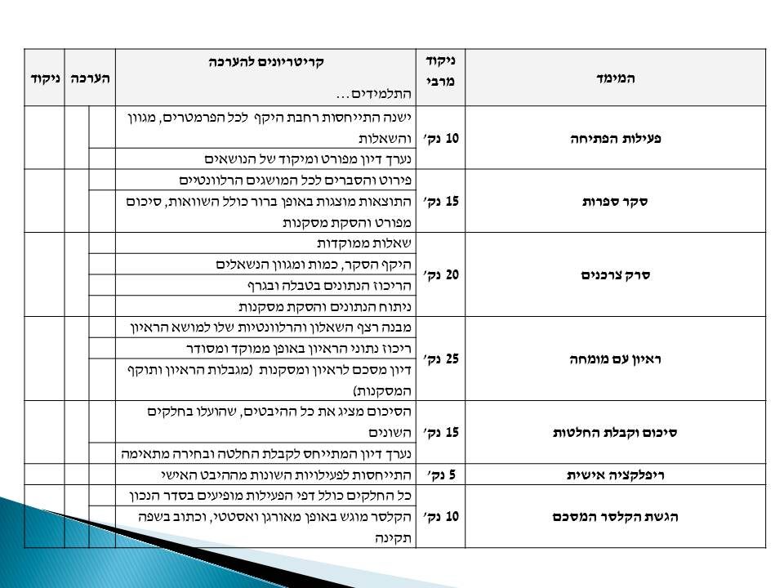

Evaluation by CPD providers
Orit is a enthusiastic novice teacher. She joined PROFILES with a good friend of hers with whom she designed the module.
During the workshop we felt ups and downs regarding the module and the project.
One of the most difficult challenges that she had to overcome was not being able to include an experiment in the module. She was sceptical regarding the interest of the students in an activity without an experiment. As she began to design the module she became aware of the importance of the skills that were included in it (network inquiry, conducting and analyzing a survey, planning and performing an interview, etc).
The big change over in her attitude occured while and after the implementation of the module. The engagment of her students who had been partly sengaged till then made her realize the strength of the project.
During the summer she presented her module to the new PROFILES workshop with such an enthusiasm that was contagious. We felt very proud and lucky to have seen her overcome such a change and a great professional development.

