PORTFOLIO for ICASE

- About myself: Description of the teacher.

My name is Duygu Seyman. I am a science teacher. I have been working as a science teacher for 5 years at a private school in west side of Turkey. My students’ ages are changing between 7-14. I am studying on environmental awareness and attitudes toward environment for my master degree.
It is very important to study with students, teachers and also specialists on the same topic who follow, learn and practice all the new trends of learning methods. As a teacher, according to me many changes and developments of learning methods had to be followed and tried to catch many kinds of attitudes of students which have different learning styles. I am really interested in actual developments in educational area. On the other hand, I am trying to procedure new activities all for my students according to their learning styles and create incomparable learning areas wherever we study for them. If you are a science teacher, you have to improve daily happenings, and show it’s basic scientific secrets to prepare different kinds of learning areas which appeal to the students attractively. This is a very important responsibility I think, because perception of students increases in these ages.

2.About my class : Description of the school and class.
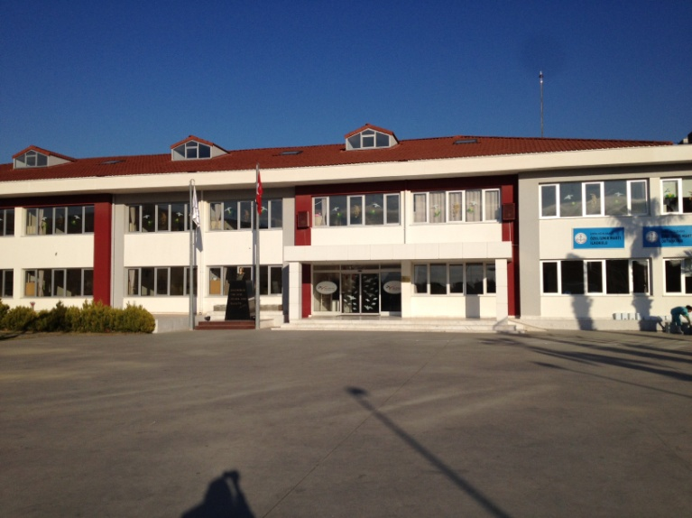
I am working at a private school in the west side of Izmir, Turkey. It has been in Güzelbah.e which is far from the city centre and so close to the natural areas. Also Izmir has equable climate that you can use this thing as an advantage to improve students’ learning areas by organizing different outdoor activities. Also we have a great science lab in our school which have different kind of activities’ conditions; 3D glasses, smart board, functional and operational lab materials, etc.

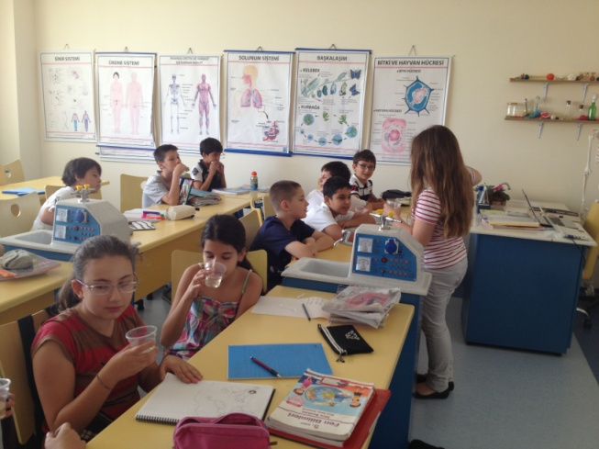
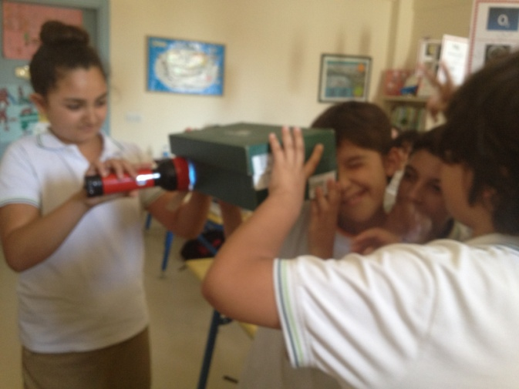
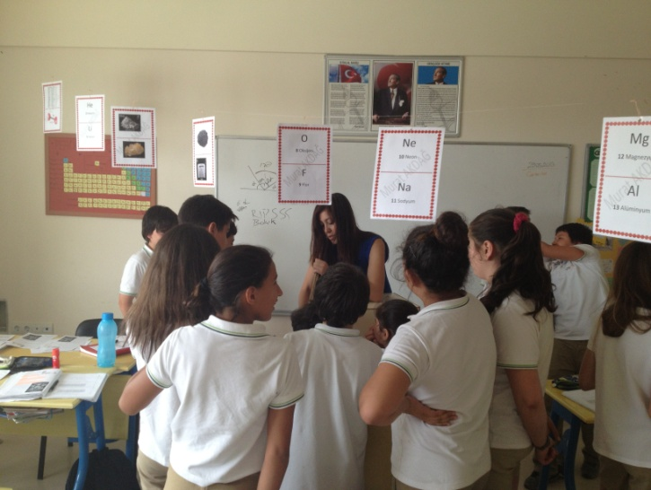
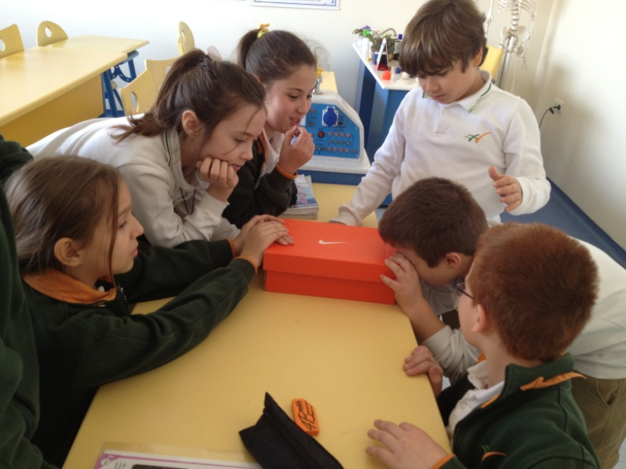
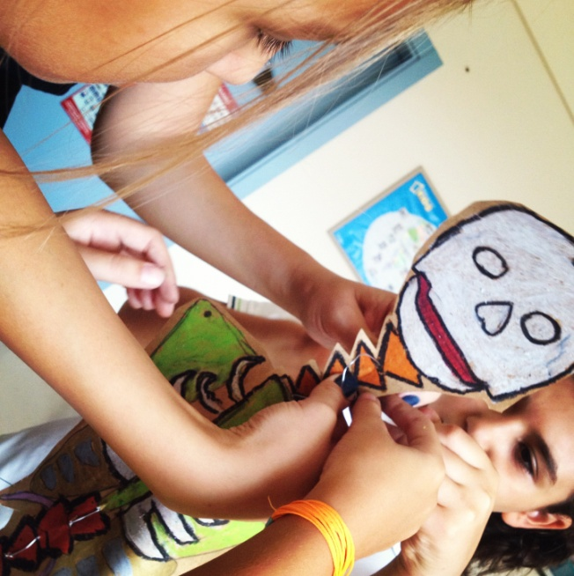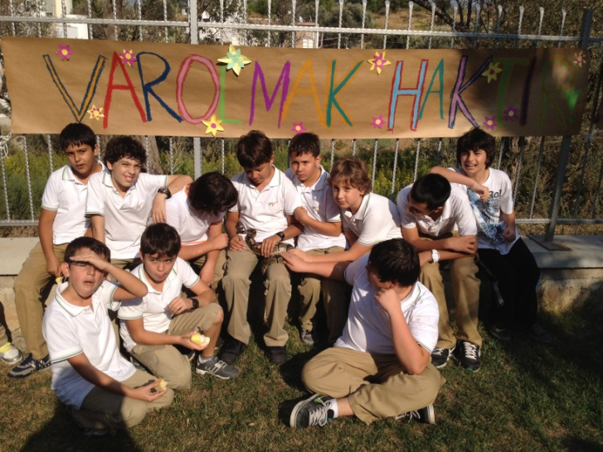

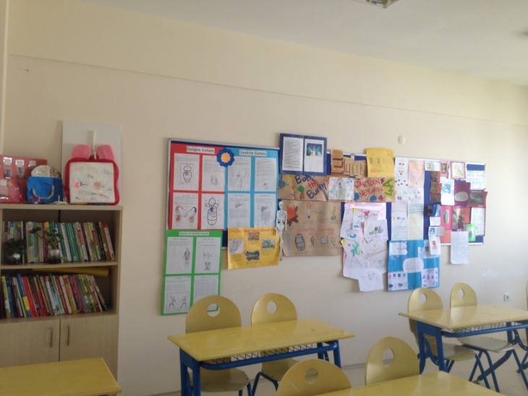
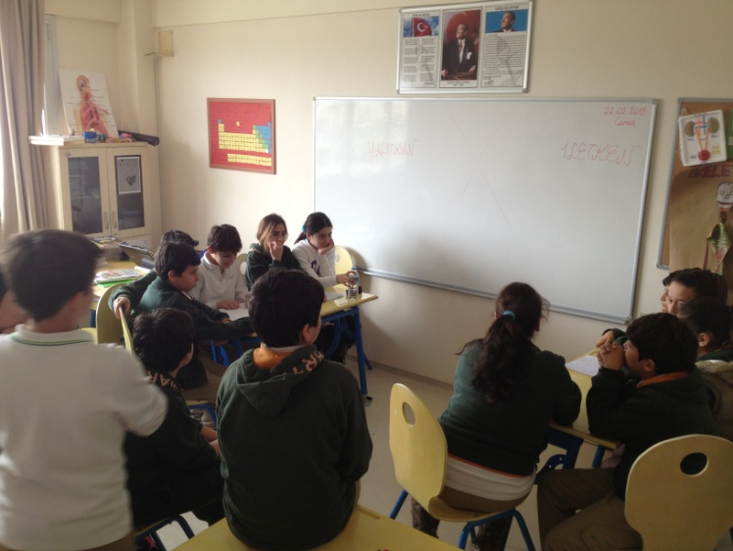

3.The module (all parts)
Are you aware of the microbes in your pocket?
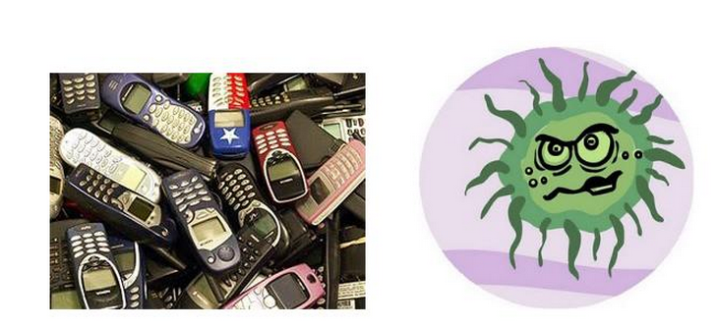
A grade 6 science (biology) module on

London School of Hygiene and Tropical Medicine by researchers from the University of London, 'in one of every six mobile phones is evidence of feces' announced. 16 per cent of mobile phones, hand in 16 percent of the people found in the intestines of E. coli (Escherichia coli) bacteria detected.
E. coli bacteria and more mobile phones can be seen in the city, with 41 percent, while Birmingham, hand E. coli bacteria common to most of the city, with 28 percent were determined to be in London.
London School of Hygiene Dr. Val Curtis, of the work done in the North and the South of England revealed differences in approach to cleaning, he said.
Dr.. Curtis, "north of the hands and mobile phones increasingly saw more bacterial host. Perhaps more so than bacteria live in cold and rainy climates or less wash their hands of the people in the north." said.
Research experts, many of that wash their hands after going to the toilet or wash their hands long enough to know right and draws attention to.

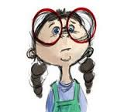

This modules leads to a decision making activity related to learn the properties and subjects of harmful and useful microorganisms.
Subject: Science and/or Biology
Unit: Human and Environment
Grade level: 6th grade
Science concepts: Active ingredient, decision-making
Kind of activity: Realize harmful and useful microorganisms
Number of lessons: 4-5 lessons of 40 minutes
Outcomes:
2.1. Body's harmful microorganisms (germs) would realize that there are natural barriers against.
2.2. Do body's immunity indicates that protects against harmful microorganisms.
2.3. Specifying the general properties of viruses and bacteria that cause diseases gives examples of daily life.

The aim of the module: being aware of the respiratory system, and this system’s organs. Recognize the system is protecting our health with respect to needs of body systems and related health problems in the correction of technological developments; realize the importance of health protection intended.
Problem Statement specified in the scenario:
According to you, what could be the reason for evidence of faecal matter in mobile phones? How can you explain it?
PHASE 1 (Questioning - prior base knowledge, forming the base for constructivist teaching)
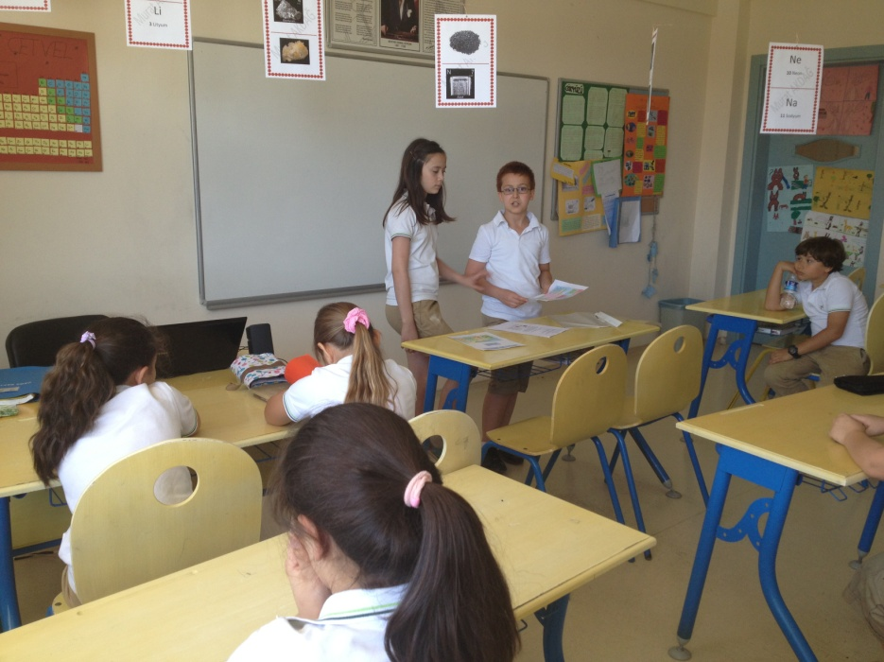
- Watching an animation about harmful microorganisms describing the illnesses
- Argumentation about the useful microorganisms
- A discussion and comparison between harmful and useful microorganisms.
Here are some questions which we use while improving our discussion: This type of microorganisms are all harmful?, How do microorganisms enter the body?, How does the body protects itself against harmful microorganisms?

PHASE 2 (Activity leading to Observation)
- Students are divided into groups.
- Worksheets are distributed to students.
- Prepared papers related to a scheme of Guided (by the teacher) Inquiry activities on immune system, harmful and useful microorganisms.
- Groups, respectively, examine different kind of microorganisms and make observations. Activities are completed.

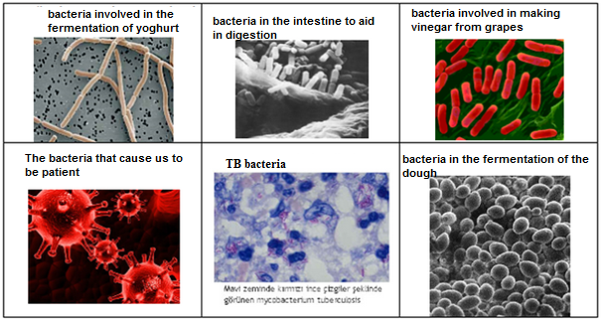
Which of the examples given in the table above do you think, are beneficial bacteria?
According to you, Which of the examples given in the table above, are harmful bacteria?

PHASE 3 (Communicating- Reflection after the implementation of a module)

Adaptation of daily life / Rating:

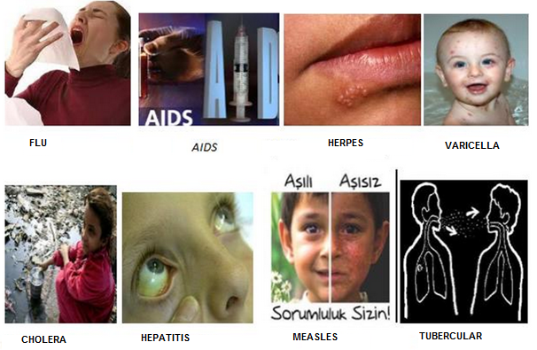
When you were a child which of the illnesses given did you suffer from?
The following table In Turkish) relates to the above photos
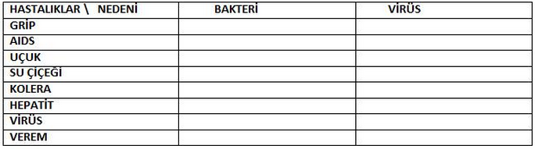

Evaluation of the module
- The names of the students in the group are recorded
- Students evaluated based on the following ___________________________
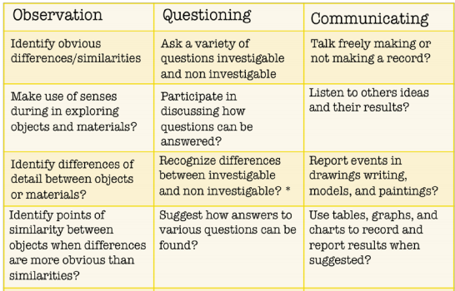
(based on “Indicators of Process Skill Development” Institute For Inquiry, 2011) www.exploratorium.edu/ifi

