The sea-sand overseas

A TEMI LESSON PLAN

Overview

What’s the mystery? | The mystery deals with sand that stays dry when water is poured onto it. Students are requested to find ways to build sand castles with this 'dry' sand.
Domain(s) | Chemistry  Chemical Bonding; Hydrophobic and hydrophilic properties.
Age group | Grades 10-12 (15-17 years old)
Expected time for the mystery | Approx. Time for teacher preparation - about an hour to prepare materials. About an hour to practice the story.  Approx. Time in classroom - Up to 6 periods of 45mn. One period to engage and explore; one to explain, 3 for open enquiry and one to present the enquiry in class.
Safety/Supervision | No safety concerns. Materials are not toxic.
Preparation & List  of Materials | - One spoon of regular sand on a petri dish per group  - One spoon of magic sand on a petri dish per group  - 50 ml of Water  - 2×100 ml beakers  - 2 droppers  - During the enquiry (the extend stage); the materials depend on the research questions of the students. They may need different solvents - oil, acetone, ethanol, hexane, heptane (hydrophobic solvents which are allowed in school), soap, etc.
learning objectives | Exposing students to practical issues related to hydrophobic & hydrophilic interactions and compounds.
Author | Dvora Katchevich, Ran Peleg, Malka Yayon, Rachel Mamlok-Naaman, Avi Hofstein and David Fortus, Weizmann Institute of Science

L Guidance notes for teachers
Engage: Capture student’s attention
The teacher tells a story about a friend who is an expert in building sand castles. The friend registers to attend a competition in a faraway place* in which he has to build a castle with a strange kind of sand (the hydrophobic sand). Students are requested to help him build a sand castle with this sand.
*The teacher can tell about a true competition that is being held, for example: http://newzealandsandcastlecompetition.co.nz/
http://www.ussandsculpting.com/

Explore: Collect data from experiments
Students examine the 'dry' sand and the regular sand in order to find a solution to the problem of building a sand castle with the dry sand. They experiment with the sand testing different solvents which will wet the sand and cause it to stick, thus allowing building a castle with it.

Explain : What’s the science behind the mystery?

The phenomenon can be explained by taking a closer look at intermolecular forces, and specifically hydrogen bonding. Regular sand can form hydrogen bonds with water thus wetting the sand grains and allowing them to stick together with the water acting as glue.

Sealsand (the 'dry' sand) is a common aggregate that has been processed and coated with a hydrophobic material thus preventing the grains of sand from forming hydrogen bonds with the water. The sand repels water but it can absorb oils and other hydrophobic solvents and pollutants.

http://sealsand.com/index-1.html

Extend: What other related areas can be explored?

Students design their own enquiry based on prior knowledge related to chemical bonding and based on the exploration with the sand (see "explore" above) in which they checked how different solvents wet the sand and allow it to stick together to form a castle .

Evaluate: Check the level of student scientific understanding
Students prepare a lab report aligned with the Israeli curriculum which assesses skills such as making observations, asking questions, designing an experiment, writing explanations and hypothesizing, etc.
Presentation of the results and conclusions can also be presented in a dramatic way (three still pictures).

Tips on how to teach and present this mystery
The full story for the engage stage can be seen in the following video - http://goo.gl/jxDnGJ
In order to fully engage the audience it is best that the teacher adds some of his personal details to the story. For example the teacher can mention where they know the sand-castle building friend from. They can mention their place of birth and that they were friends from kindergarten. In short, personal details added to the story can make it more vivid, gullible and engaging.

Teaching Skills using Gradual Release of Responsibility

Notes: Most Mysteries can also be used to teach Enquiry skills. A ‘Skill-teaching ’ TEMI lesson needs to use a modified 5E cycle where the Explain stage precedes the Explore. This is because it is necessary for the teacher to model the skill before, students practice it, as described in the box below:
This activity is open ended.
In the engage stage the teacher just tells a fictional story with no demonstrations. Since this activity deals with materials from students' everyday life, there is no need to demonstrate.
In the explore stage, students are given freedom to conduct their own enquiry into the phenomenon. This enquiry is paced by the students with the teacher offering minimum support. At this stage students should arrive with a solution of how to make the sand stick.
In the extend stage, students devise their own enquiry activity. Here they ask their own enquiry questions, design their own enquiry experiments, order materials and conduct the experiments. This might be a big leap for some students and at this stage they will need the teacher to guide their planning. The teacher's role, however, should be one of a consultant rather than an instructor.

THE STUDENT WORKSHEET CAN BE COPIED AND USED IN THE CLASSROOM

Student worksheet

Introduction to mystery
Our good friend James is a champion sand-castle builder. He won every com-petition in Europe. But one day he went to a competition in Australia and all he got was this magic sand. At first he was convinced he would lose. But guess what, he built a sand castle after all!!
Now it's your turn - can you?
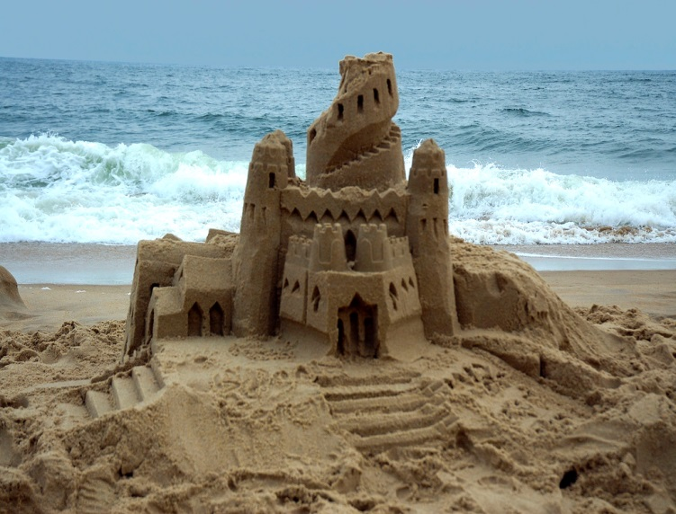

Engage What’s interesting?

Task: | James provided us with two types of sand: regular and special sand.  Add some drops of water to each type of sand to see what James saw when trying to build the sand castle in Australia.  http://stwww.weizmann.ac.il/g-chem/temi/sand3.html  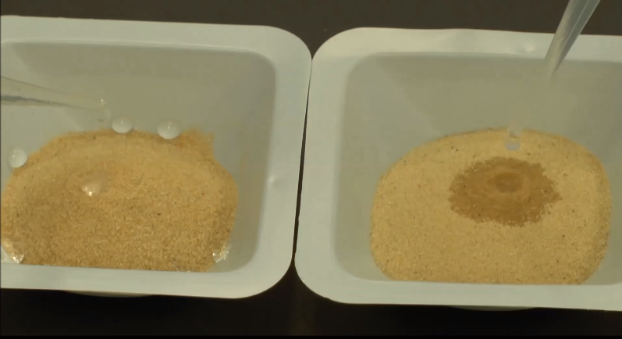

Explore What’s happening?

Task 1: | Try building a sand-castle from the special sand.  Do you need any extra tools or materials?
Task 2: | Explore the behavior of the sand with the tools and materials you requested

Explain What’s causing it?

Task 1 | Explain: What are the properties of the "special" sand that prevent water from wetting it?
Task 2 | What do you think is the chemistry underlying the "special" sand?
Task 3 | Look at the model below representing the surface of regular sand at the molecular level. How can you explain the fact that water wets this sand? In what way must the special sand be different than the regular sand below?
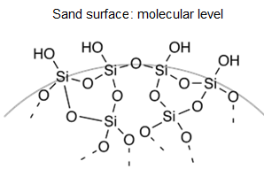
Credits:http://commons.wikimedia.org/wiki/File:Schematic_silica_gel_surface.png

Extend What’s similar?

Task 1: | Write five questions that arose while exploring the "special" sand?
Task 2: | Choose one of the questions that you would like to investigate regarding the "special sand castle" and formulate this question clearly as an enquiry question?
Task 3: | Clearly formulate a hypothesis that relates to the question that you chose to investigate. Give reasons for your hypothesis, based on correct and relevant scientific knowledge.
Task 4: | Plan an experiment that will check your hypothesis.  • Detail all the steps of the experiment, including the control stage.  • List the equipment and materials needed on the equipment request form.  • Consult with the teacher and make changes if necessary.  • Submit the list of equipment and materials to the laboratory technician.  In the next lesson, you will perform the lab experiment you devised.

Evaluate What’s my understanding?

Task 1: | Prepare a lab report.
Task 2: | The results and conclusions can also be presented in a dramatic way. In groups try to think how you can explain the phenomenon using a story, a short play or a mime piece. Present your drama to the rest of the class.

Could also include if appropriate

My Hypothesiser Lifeline

Hypothesis 1

Things I can do to test this

Results of test

Reason for rejection/acceptance of hypothesis

Hypothesis 2

Things I can do to test this

Results of test

Reason for rejection/acceptance of hypothesis

