Explore
It was a normal Tuesday morning, February 20th, 1943. Dionisio Pulido was still on his floor mat gathering the energy to start the day. He lived with his family in a hut in a small village close to Uruapan in Mexico. Eventually he got up, gathered his family, harnessed his old mule and started marching to his cornfield. Once in the field everyone got busy doing their daily routine around the field. The mule lazily pulled the plough, Dionisio was busy driving the mule and contemplating about this year's harvest and his family was roaming the field checking the soil.
All of a sudden a loud cracking noise was heard for a few seconds. Then another one. Everyone looked up from their duties to see where the other family members were. They all seemed to be alright. Maria, the youngest daughter started yelling: "Come here!!". They all gathered around a crevice that just formed. From the crevice a red liquid flowed that looked like octopuses tentacles. A horrible stench of Sulphur was to be noticed. Dionisio, who thought the devil has come to take him immediately evacuated his family to safety until everything settled down.
After praying all night, Dionisio arrived in the field the next day to see if the devil has left. From far away a small hill could be seen that wasn't there before. The hill was again covered with these strange octopuses' tentacles. Before he could get an closer, a huge explosion occurred. Red hot stones were blown into the air and scattered all over the field. By the end of the day the little hill grew by 20 meters. The hill grew ferocious emitting fumes, gases and ashes.
Poor Dionisio lost his field. He also lost his home as did the residents of two nearby villages. Over the next nine years Parícutin continued to grow to 450 m above the surrounding area reaching an overall altitude of 2800 m above sea level. Three people were killed, two villages had to be evacuated, an area of 233 km² was destroyed and two new towns were built to accommodate evacuees.

…And it all began on a quite Tuesday morning…

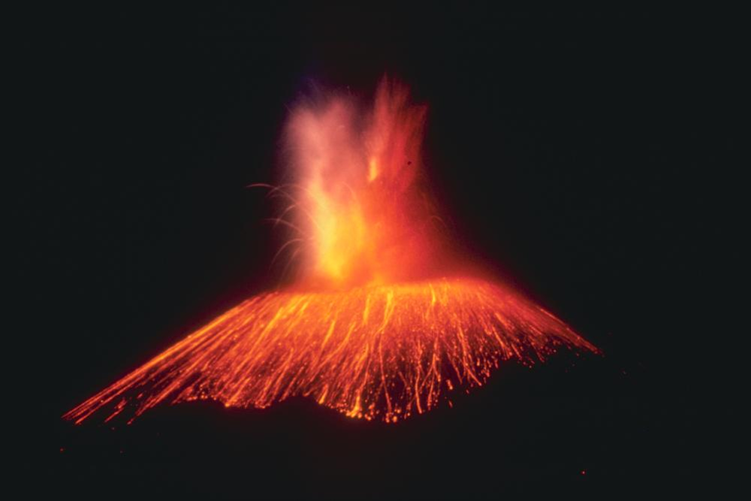  Parícutin in an eruption in 1943¹  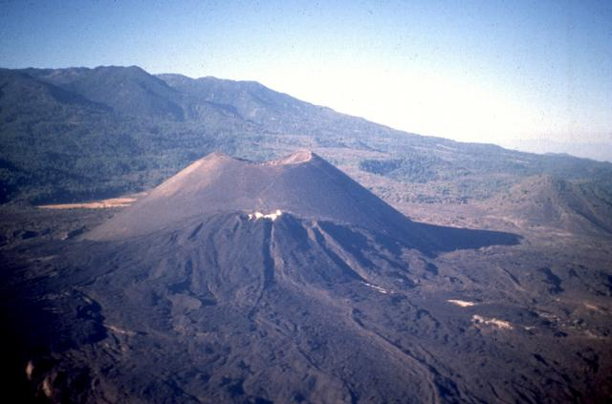  Parícutin in its full size in 1997² |  | 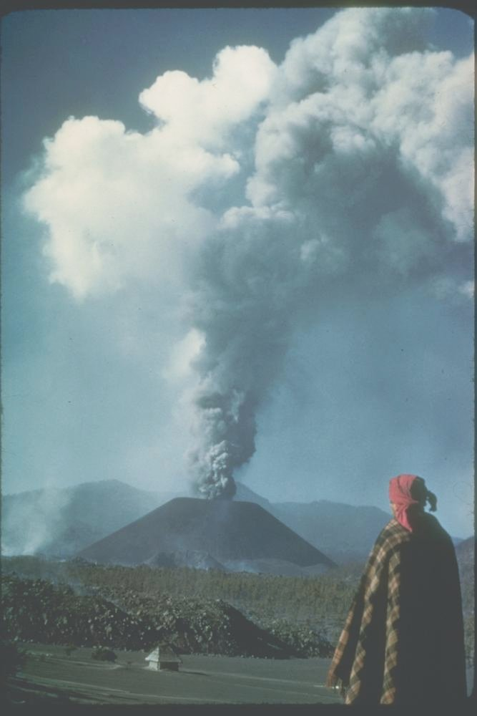  Parícutin growing from a cornfield in 1943³
Assignment:

- Was Parícutin's erruption in the cornfield foreseeable?

- Could Dionisio have done something to avoid the erruption?

- Could you describe the stages of a volcanic erruption? Is the process quick or slow?

- What are the chemical processes described in the story.

Explore | Preliminary experiment  - Read all the instructions well before starting the experiment.  - Check that you have all necessary equipment and materials.  Equipment and materials:  Two 500 ml beaker  One 100 ml graduated cylinder  a spoon  an electric hotplate  tap water  sand  candle wax  Procedure:  - Place the wax at the bottom of the 500 ml beaker. Try to place the wax as close to the centre as possible.  - Use the second 500 ml beaker to measure 200 ml of sand.  - Pour the sand over the wax in the first beaker.  - Use the second beaker again to measure 200 ml of water.  - Slowly and carefully add the water to the system.  - Place the beaker with the wax, sand and water on the hotplate and turn it on.  - Make a note of your observations. Be careful, some things happen very suddenly.
Explain
- Describe the processes that happen in the system during the heating.

- Suggest scientific explanations for the processes that occur in the system.

- Try to explain the process in terms of chemical structures and bonding and relating to each of the following materials: wax, water and sand.

Extend | - Formulate at least 5 relavant and diverse questions that you many have following the observations of the experiment.  - Choose one question which you would like to investigate.  - Formulate the research question in a clear manner. Try to formulate it as a correlation between two variables.  - Formulate a clear hypothesis relating to the research questions.  - Justify your hypsothsis based on the obervations and your knowledge of chemistry.  - Plan an experiment that could examine your hypothesis:  - Define the dependent and independent variables.  - State how you intend to measure the dependent variable.  - State the controlled variables (constant variables) in the experiment.  - Write a detailed procedure for all stages of the experiment. Don't forget to relate to the control. Make sure the procedure is explained clearly and in a logical order.  - Attach a detailed list of all equipment and materials needed to conduct the experiment.  - Obtain the teacher's permision to conduct the experiment you planned.  - Submit the detailed list of equipment and materials to the lab technition.  - Conduct the experiment you planned as it was approved by the teacher.  - Make sure you conduct clear, detailed and careful notation of the observations.  - Present the observationations and all results in an organized manner (a table or a figure).  - Try to process the results into a graphical form.  - Describe any trends that appear in the data.  - Analyze and explain the results based on relevant knoledge.  - Can you reach any conclusions based on the results of your experiment?  - To what extent do the conclusions support your original hypothesis?  - In a classroom discussion:  - Relate to the results in a critical manner (limitations, accuracy, etc.)  - Relate in a critical manner to the validity of the conclusions.  - Are there any changes that should be improved if the experiement was to be conducted again?  - List any further questions that you may have following the experiment.

Evaluate | - Submit a well organized lab report that is written in scientific language?  - Prepare a presentation for the classroom that shows and explains the results you found. Relate to the particular (micro) level as well as the macro level of the phenomenon.

Sources:
¹ - R.E. Wilcox, U.S. Geological Survey - http://www.ngdc.noaa.gov/seg/hazard/slideset/30/30_613_slide.shtml
² - Jim Luhr, Smithsonian Institution - http://www.volcano.si.edu/world/volcano.cfm?vnum=1401-06=&volpage=photos&photo=058004
³ - K. Segerstrom, U.S. Geological Survey - http://www.ngdc.noaa.gov/seg/hazard/slideset/30/30_612_slide.shtml

