PROFILES IBSE Teaching/Learning Materials – Overview
Compiled by the PROFILES Working Group of the Weizmann Institute of Science, Israel

Plastic: Reduce the use!

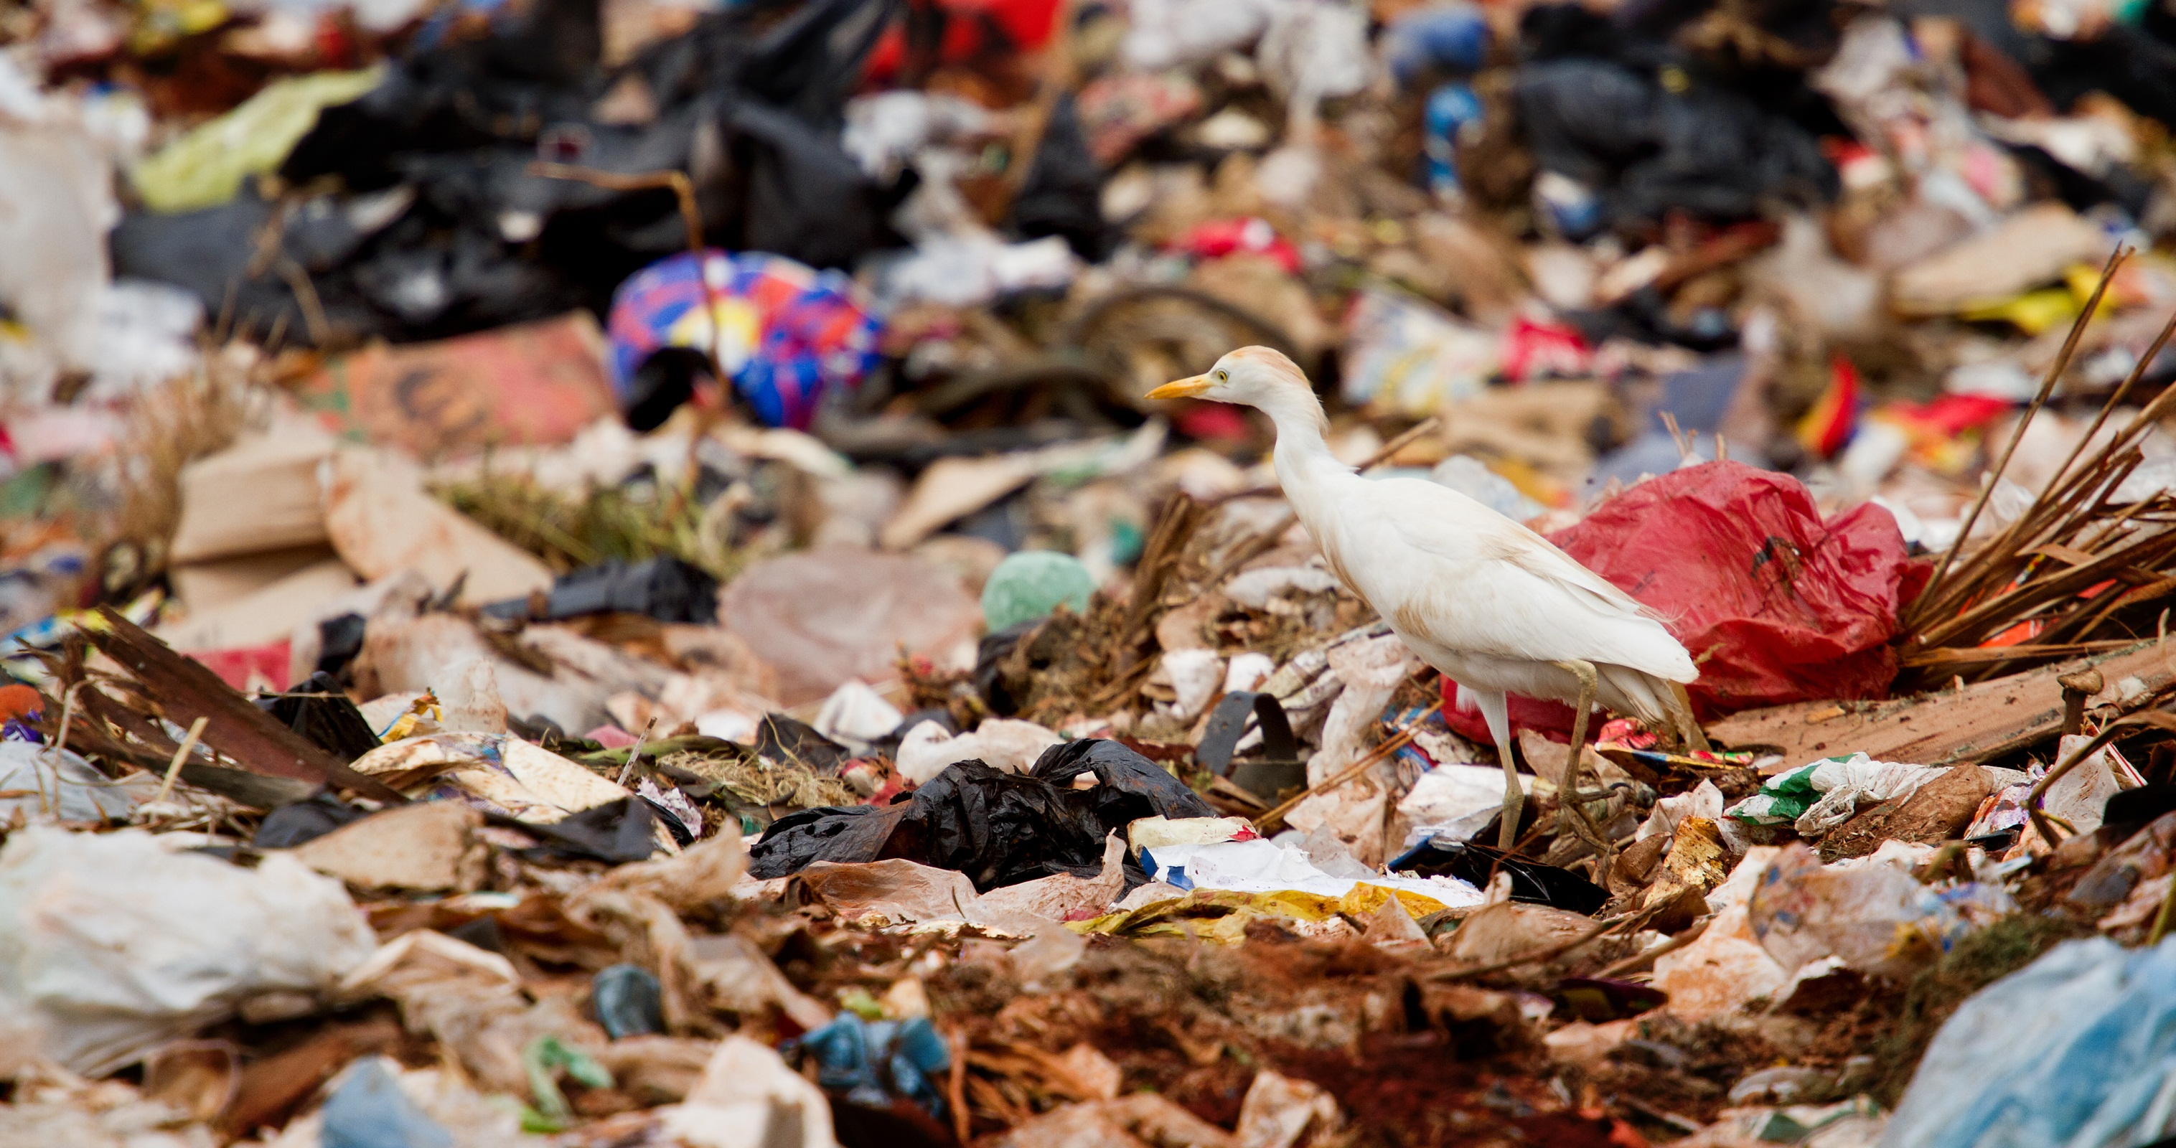
A module on plastic products: structure, and environmental impact for Grades 10 to 11

Leaders: Avi Hofstein and Rachel Mamlok-Naaman
Developed by: Sandra Azuelos-Kats, Afrah Assi, Pavel Kuzmin.
Edited by: Dr. Dvora Katchevich and Dr. Rachel Mamlok-Naaman.
Institution: Science Teaching Department, the Weizmann Institute of Science – Israel
Homepage: http://stwww.weizmann.ac.il/g-chem/profiles/

Abstract
This module is designed in purpose to expose the students to the convenient use of plastic products on the one hand, and to the environmental impact caused by over-using those products on the other one. We, the developers of this module, wish that this module will develop the sense of responsibility of chemistry students to the environment, by increasing their awareness to the environmental impact of imperishable polymers and by exposing them to other possibilities such as recycling and alternative exhaustible materials. They might be our ambassadors on their houses.
Subject: Science and/or Chemistry
Grade level: 10th to 11th grade
Science concepts covered: Polymers, repeating unit, exhaustible polymers, solubility of polymers in water.
Kind of activity: Enquiring, explaining, laboratory work, group activities etc.
Number of lessens: 4-5 lessons of 45 minutes
Learning outcome/competences:
During this module, students are expected:
- to know and understand new concepts ,such as:
- Polymer, structure of polymers, repeating unit.
- plastic
- exhaustible polymers

- to develop their competencies on :
- making a decision
- critical thinking
- working on a group
- Expressing their thoughts and feelings orally.
- Reading comprehension of texts.

- to be exposed to the relevance of chemistry ,for example:
- Various uses of plastics on our daily life.
- The negative influence caused by the un-perishable plastic waste on the environment.
- to carry out experiments and :
- Explain the results based on the microscopic structure.
- Articulate a research question.

Attached files
1. | Student activities | - Introduction: Pictures interpretation.  - Watching a Power point presentation about polymers.  - Reading texts and answering questions.  - Carrying out experiments:  - Production of nylon.  - Testing the solubility of P.V.A. and P.E. in water.  - Thinking tools for making a decision.  - Presentations: Each group should present its text, attitudes and explanations.
2. | Teaching guide | As an introduction of the module, the students are shown pictures of environmental pollution caused by plastic products and dead animals lying on a shore which is full of plastic bags. The students are requested to express their feelings and thoughts about the pictures. The first activity is a Power Point Presentation which includes new concept definitions such as: polymer, repeating unit, recycling, and exhaustible polymers. The second activity is reading a text about a turtle which almost dies as a result of eating an inedible plastic bag thrown on the shore. The students answer the questions which follow the text. On the third activity the students carry out two experiments: production of Nylon and testing the water solubility of polyethylene bag and polyvinyl alcohol bag. The students are required to provide a micro explanation for the results: P.V.A. is soluble in water, in contrast to the P.E. which is insoluble in water. On the 4th activity the students work into groups using a thinking tool. They are supposed to suggest alternative ways which might reduce the negative influence resulted from the accumulation of plastic waste such as: taxes on plastic production, minimizing the usage, recycling, using green environmentally friendly products. Furthermore, they are expected to make a decision and choose the alternative way which they prefer for achieving the target. Finally, on the 5th last activity, they present their decision and justified reasons.

Acknowledgement:
The idea for the experiment of this module was taken from the Teaching-Learning Materials Tool compiled by the PARSEL Consortium (namly by Streller, Benedict, & Bolte, 2007) as part of the EC FP6 funded PARSEL Project (SAS6-CT-2006-042922-PARSEL) and adapted by the FUB-PROFILES Working Group – Member of the PROFILES Consortium. For further information see: www.parsel.eu.

