PROFILES IBSE Teaching/Learning Materials – Overview
Compiled by the PROFILES Working Group of the Weizmann Institute of Science, Israel

Plastic: Reduce the use!

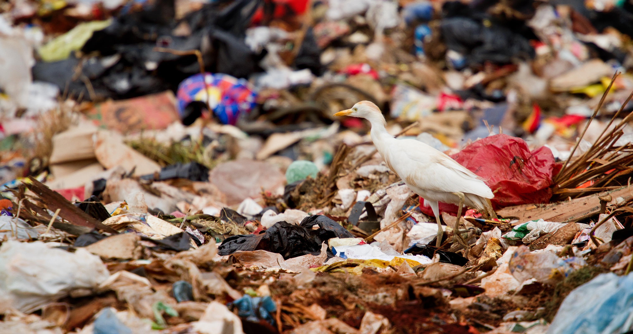
A module on plastic products: structure, and environmental impact for Grades 10 to 11

Leaders: Avi Hofstein and Rachel Mamlok-Naaman
Developed by: Sandra Azuelos-Kats, Afrah Assi, Pavel Kuzmin.
Edited by: Dr. Dvora Katchevich and Dr. Rachel Mamlok-Naaman.
Institution: Science Teaching Department, the Weizmann Institute of Science – Israel
Homepage: http://stwww.weizmann.ac.il/g-chem/profiles/

Summary of activities
- Introduction: Pictures interpretation.
- Watching a P.P.P. (Power point presentation)
- Reading texts and answering questions.
- Carrying out experiments:
- Production of nylon.
- Testing the solubility of P.V.A. and P.E. in water.
- Thinking tools for making a decision.
- Presentations: Each group should present its text, attitudes and explanations.

Timetable:
Lesson number | activity | Anticipated time (minutes)
1 | Picture interpretation | 20
 | P.P.P. | 20
2 | Reading texts | 45
3 | Experiments | 45
4 | Thinning tool | 45
5 | presentation | 45

Activity number (1):
Picture interpretation – the students are divided into groups of (4) students .Each group receives one picture and is required to answer the questions that follows. The goal of this activity is to raise the issue of the overusage of plastic and its resistance to degradation.
Power point presentation (P.P.P.) – This activity may be performed in two possible ways:
- By the teacher with the whole class.
- Into groups in a computer class.

The goal of this activity is to get acquainted with the basic scientific concepts related to polymers.

Activity number (2): Reading texts
The students are divided into groups of (4) students .Each group reads the text and is required to answer the questions that follows.
The following questions:
Why is food not a problem when taken into the stomach, but plastic bags are? How can plastics bags be made harmless after use? Why are plastics so resistant to change/decomposition? provide a lead to Activity 3. It is important for the teacher to emphasize the connection between the questions asked and the need to know which will be partly answered in the following experiments, this is THE ESSENSE (IL-inquiry learning & ES education through sience) in the PROFILES rationale.

Activity number (3): Carrying out experiments
Each group carries out two experiments in order to experience some charachteristics of polymers:
- Production of Nylon (from soluble monomers to insoluble polymers.
- Testing the water solubility of :
    - Polyethylene.(P.E.)
    - Polyvinyl alcohol. (P.V.A.)
One of the important stages in the degradation process is solubility (more details are given in scientific background)

Activity number (4): Making a decision using a thinking tool.
Each group is required to use a thinking tool (gain – loss - analyzing), in order to teach how to make a reasonable based decision. This is done in the group. The aim of this activity is to show the student the impact of plastic usage at a social level.

Activity number (5): presentation
Each group represents its decision and its justified reasons. This is a proper scenario to summarize the advantages, disadvantages and implications of the overuse of plastic, and the thinking tool for decision making.

Notes for the teacher:
- This Module may help demonstrating the relevance of chemistry and plastic to our daily life.
For example:

- Polyvinyl alcohol bags are used as collecting laundry bags in hospitals. This polymer is soluble in water.
- Bottles which are collected for recycling are used to produce fibers.

- You may elaborate the subject of functional groups:
carboxylic acid, alcohol and side groups in the P.V.A..
- You can expand on the solubility of P.V.A. and P.E. :
hydrophilic groups, hydrophobic groups, you can have students draw the hydrogen bonds between one repeating unit of P.V.A. and two water molecules.

Research questions that students should formulate after the experiments in activity number (3):
- What is the relation between the polymer solubility in water and the temperature of the water?
- What is the relation between the polymer solubility in water and the polymer's structure?

Scientific background regarding the module:
- Student's scientific background: The power point presentation.
- Teacher's scientific background :
The production process of poly-vinyl-alcohol bags:
.
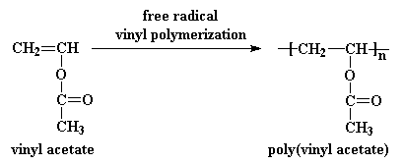

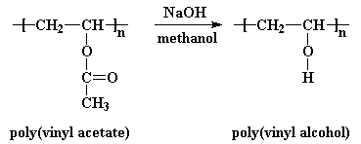

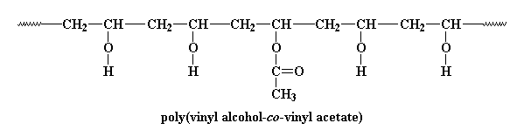
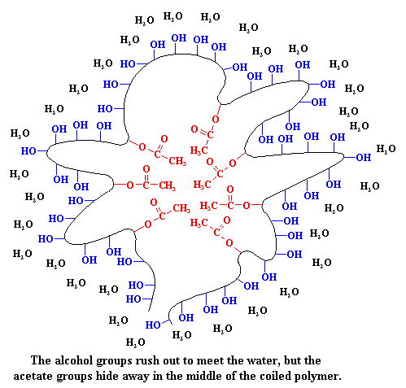
The polymer solubility in water:

A student questionnaire
Answer the questions below .Choose an answer from 1-4.
- Not at all
- A little
- Much
- Very much
 | Questions | 1 | 2 | 3 | 4
1 | Did you know that most of the plastic products are inexhaustible?
2 | Did the module expand your knowledge?
3 | Did you expect that plastic bags might be soluble in water?
4 | Did the module cause you to think differently about your plastic usage habits?
5 | Were the experiments interesting for you?
6 | Was the text interesting for you?
7 | Do you think that you might change your habits on using plastic products after this module?
8 | Was it easy for you to make a decision at the end of the module?
9 | Do you think that there is a lack of awareness regarding overusing plastic products?
10 | Did you agree with your classmates on the decision you made?

- Which parts of the module you liked the most?
- Which parts of the module helped you to make a decision?
- How do you suggest we may increase the awareness of people about the accumulation of plastic waste?

A teacher questionnaire

Answer the questions below .Choose an answer from 1-4.
- Not at all
- A little
- Much
- Very much
 | Questions | 1 | 2 | 3 | 4
1 | Was the module taught for 4-5 .lessons?
2 | Did the experiment contribute to achieving the goals of the module?
3 | Didthe discussion of the goals contribute to improving the module?
4 | Did the presentation contribute to achieving the goals of the module?
5 | Didthe students have found serious reading texts?
6 | Do you think that the length of the module is reasonable?
7 | Was it easy for students to cope with the decision tool?
8 | Were the students serious and interested in performing the experiments?
9 | Did the module achieve its goals?

- Do you think that the students were able to develop a negative attitude regarding the use of excessive plastic?
- Do you think that the students were able to take a stand and make a decision on "How can we minimize plastic waste"?
- If you were forced to shorten - what parts of the module would you skip?
- What changes would you make in the module?

Bibliography:
- www.orianit.edu-negev.gov.il/kayamut/cp/.../michzurlearn.htm-clickit.ort.org.il/files/upl/109142845/496255934.doc -www.matar.ac.il/EndOfPlastik.asp
- http://www.matar.ac.il/
- http://pslc.ws/macrog/pva.htm
- www.recycling.co.il/11/www.yerookim.co.il/article.aspx?id=187
- www.ynet.co.il/articles/0,7340,L-3175518,00.html
- lib.cet.ac.il/pages/item.asp?item=2699
- www.adamteva.org.il
- www.recycling.co.il/01/

