PROFILES IBSE Teaching/Learning Materials – Overview
Compiled by the PROFILES Working Group of the Weizmann Institute of Science, Israel

Can used oil be the next generation fuel?
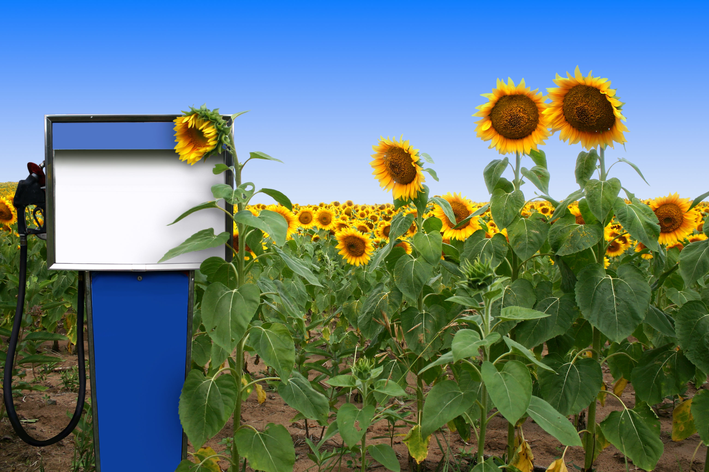
A Module for Science Instruction – especially Chemistry – for Grades 9 to 10

Leaders: Avi Hofstein and Rachel Mamlok-Naaman
Developed by: Lira Ezra, Bela Shkolnik, Jawad Agbaryia
Edited by: Dr. Dvora Katchevich and Dr. Rachel Mamlok-Naaman
Institution: Science Teaching Department, the Weizmann Institute of Science – Israel
Homepage: http://stwww.weizmann.ac.il/g-chem/profiles/

Abstract

Energy crisis is here. With the increase in world population the demand for fuel and energy sources is increasing too. Most of the energy sources are derived from petroleum. These sources pollute the environment. One of the alternative energy sources is biodiesel, and it derives from plants or from used oil plants. Through the module we can expose the students to existing energy sources and the alternative biodiesel.
Subject: Science and/or Chemistry
Grade level: 9th to 10th grade
Science concepts: Combustion of carbon compounds, pollution, energy.
Kind of activity: Enquiring, explaining, laboratory work, group activities etc.
Number of lessons: 4-5 lessons of 45 minutes
Learning outcomes/competences:
• Understanding the reasons for the energy crisis.
• Comparison of available fuels with biodiesel.
• Identification of the advantages and disadvantages of the fuels that are compared.
• Introduction to biodiesel: sources, efficiency, and possible uses.
Skills
• Searching for information about fuels.
• Critical thinking about advantages and disadvantages of different fuels.
• Asking questions, formulating hypotheses and planning an experiment.
• Presentation of results and conclusions.
• Decision making based on experiment results.
Attached files
1. | Student activities | 1- World energy crisis-scenario.  2- Comparison of fuels – network inquiry.  3- Experiment design – inquiry.  4- One picture is worth 1000 words – conflict regarding the use of food for nutrition or as fuel.  5- Critical reading of a scientific article  6- An experiment aimed at comparing the efficiency of fuels.
2. | Teaching guide | The scenario will trigger a class discussion about the world energy crisis, and examine some articles from the newspapers, in order to understand the causes and possible solutions and the reason for studying the topic.  In the next activity the students compare different fuels including biodiesel, according to the information from the internet and from experiments done in class they choose the best fuel from a list of possible sources.  The module rises the conflict regarding the use of food for nutrition or as fuel.

Acknowledgement:
The idea for the experiment of this module was taken from the Teaching-Learning Materials Tool compiled by the PARSEL Consortium (namly by Streller, Benedict, & Bolte, 2007) as part of the EC FP6 funded PARSEL Project (SAS6-CT-2006-042922-PARSEL) and adapted by the FUB-PROFILES Working Group – Member of the PROFILES Consortium. For further information see: www.parsel.eu.

