PROFILES IBSE Teaching/Learning Materials – Overview
Compiled by the PROFILES Working Group of the Weizmann Institute of Science – Israel

Can used oil be the next generation fuel?
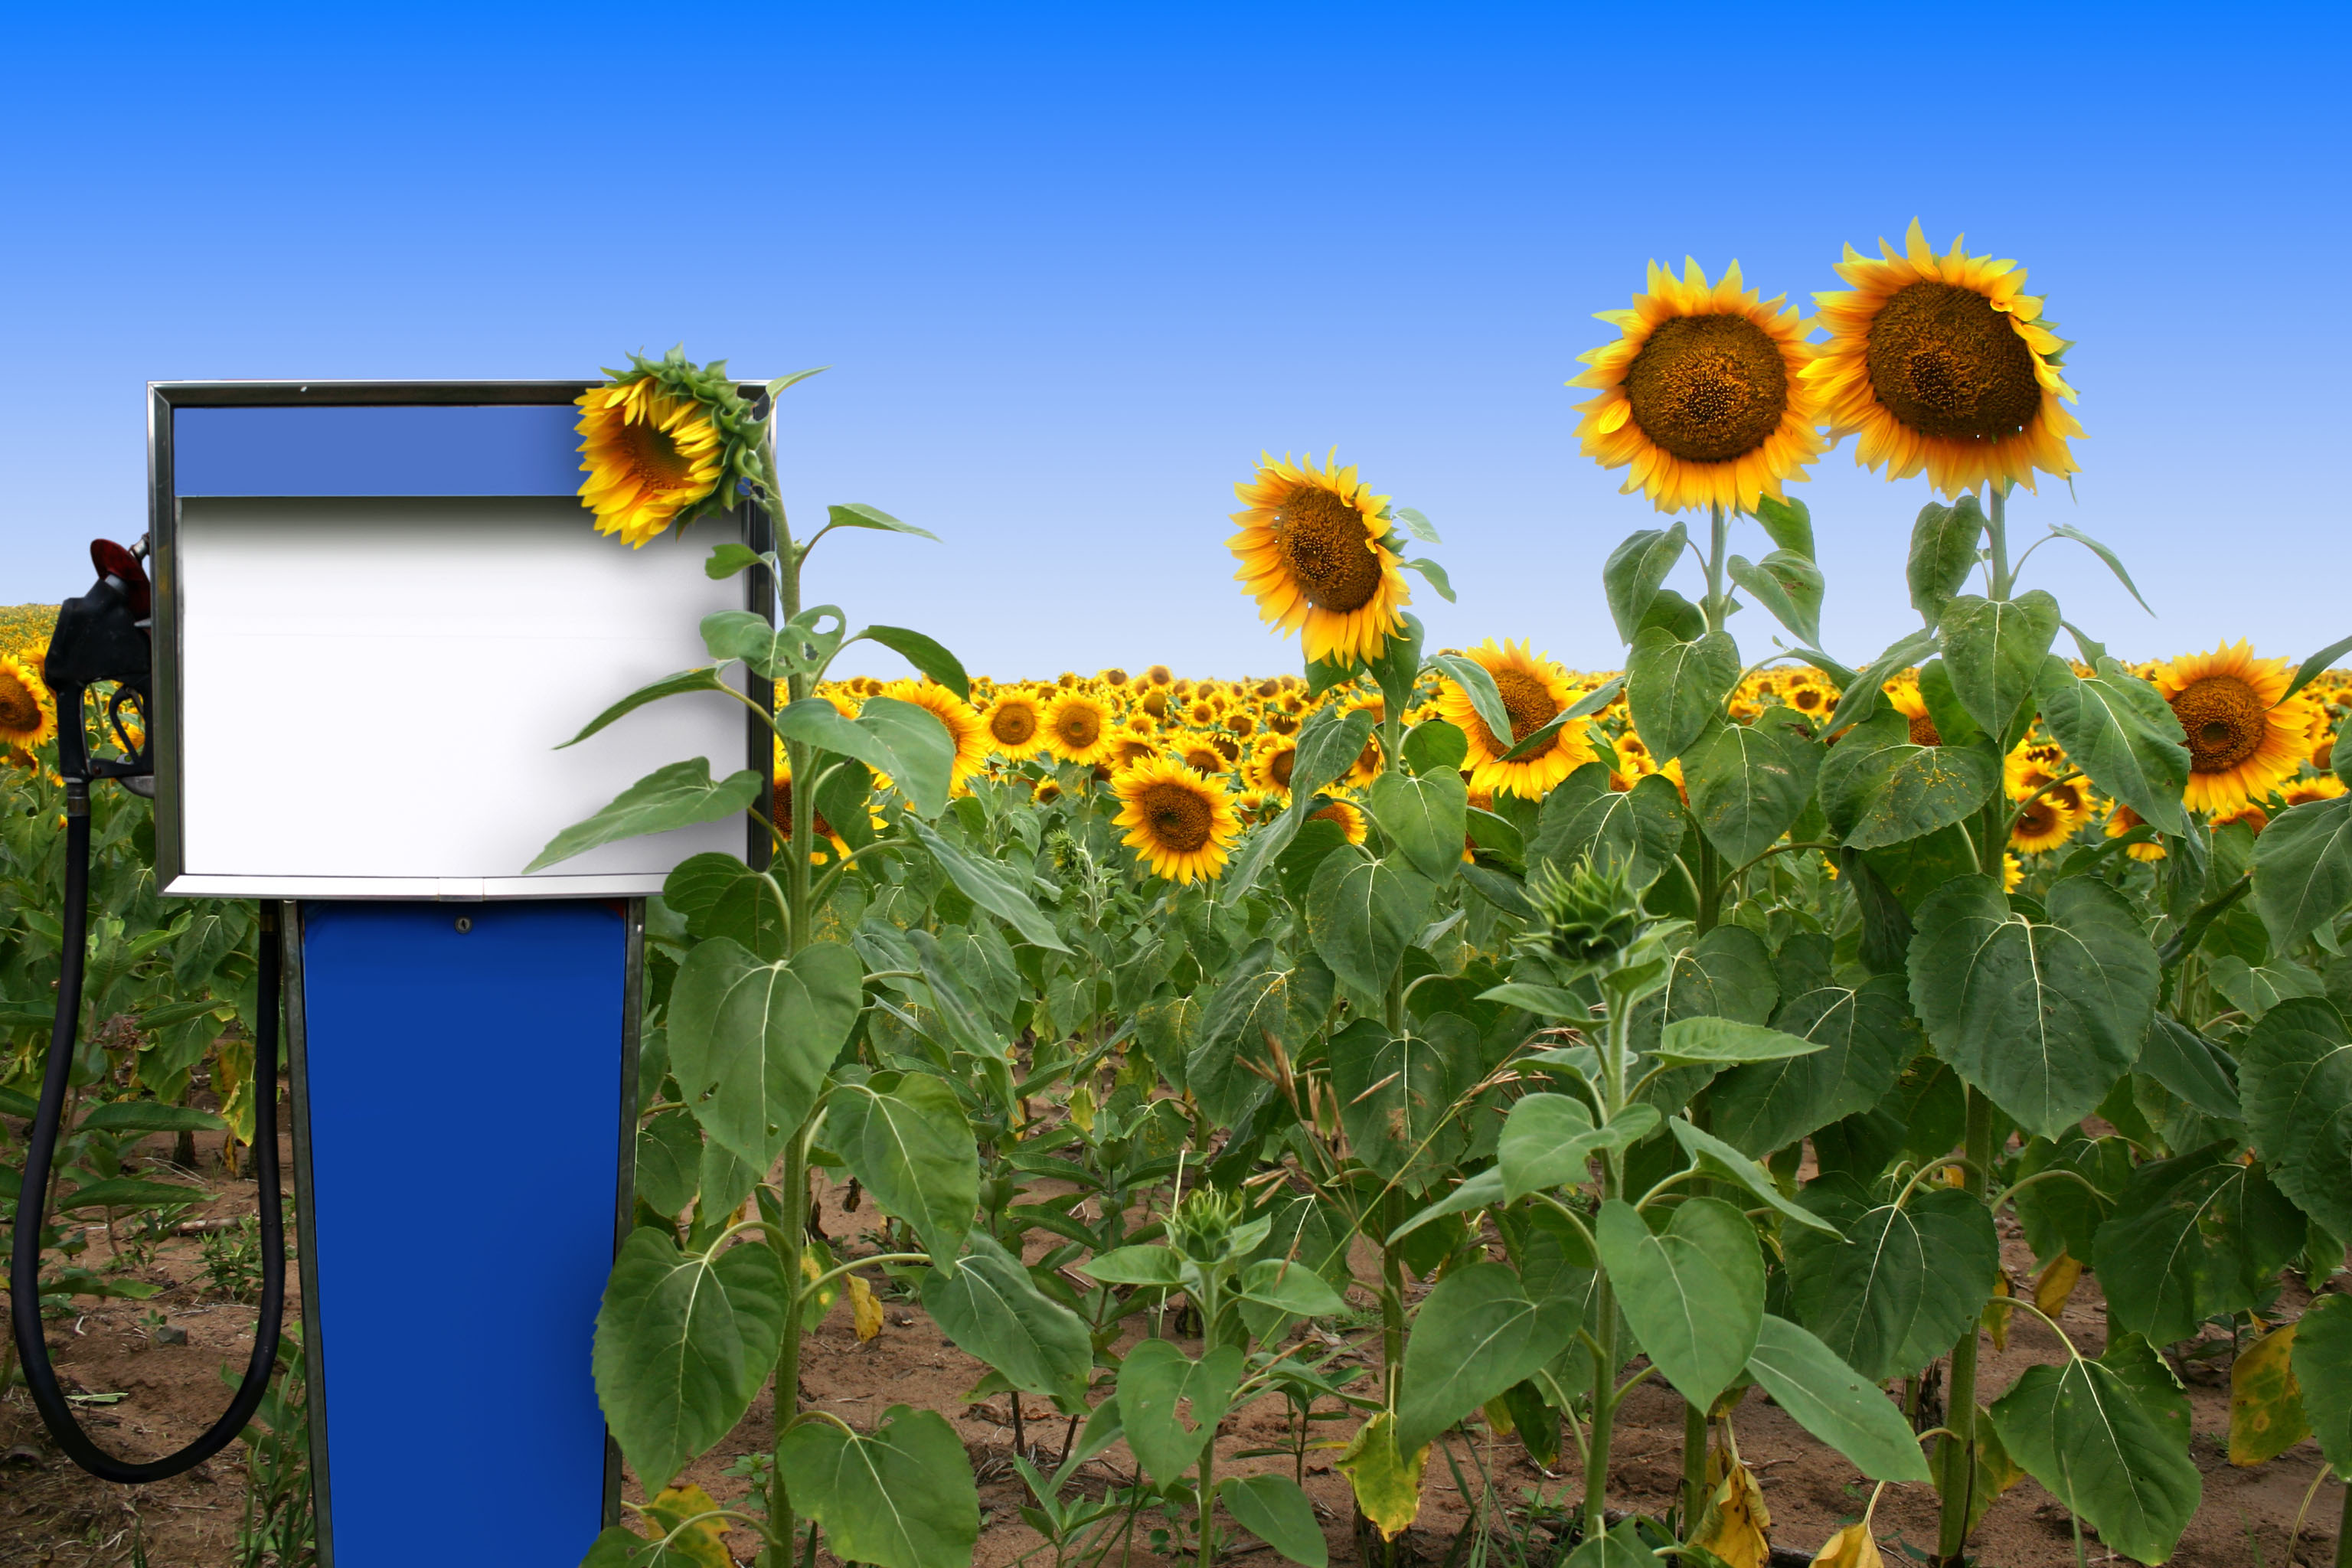
A Module for Science Instruction – especially Chemistry – for Grades 9 to 10

Leaders: Avi Hofstein and Rachel Mamlok-Naaman
Developed by: Lira Ezra, Bela Shkolnik, Jawad Agbaryia
Edited by: Dr. Dvora Katchevich and Dr. Rachel Mamlok-Naaman
Institution: Science Teaching Department, the Weizmann Institute of Science – Israel
Homepage: http://stwww.weizmann.ac.il/g-chem/profiles/

Module Content

Summary of activities

Activity 1- world energy crisis
We will have a class discussion about the world energy crisis, and examine some articles from the newspapers, in order to understand the causes and possible solutions.

Activity 2- comparison of fuels
The students will:
- Compare different fuels including biodiesel.
- Choose the best fuel from a list of possible sources.

Activity 3-Experiment design
- The student will propose an experiment in order to compare the efficiency of different fuels.

Activity 4-one picture is worth 1000 words
- Understanding of problems and solutions by viewing images and formulating questions.
- Enhancing creative thinking.

Activity 5- critical reading of a scientific article
The students will be asked to read a text from a scientific article, interpret graphs and tables and reach conclusions.

Activity6- an experiment aimed at comparing the efficiency of fuels
The students will:
- Compare between gasoline, diesel and biodiesel (from used plant oil) by measuring the time which is needed to heat water to 50°C.
- Draw conclusions from their observation regarding the burning fuels.

*The students' activities are represented in the following pages.

Teacher guide

This module enables students to learn about:
- Energy crisis.
- Cause the energy crisis.
- Various sources of fuel production.
- Biodiesel, diesel and gasoline.
- Understand advantages and disadvantages of energy sources that are tested.
- Different ways to determine the efficiency of fuel are based on appropriate laboratory and based on independent information search.

Activity 1- world energy crisis
This is the opening scene which exposes the students with a very crucial problem. Students read articles from newspapers, which the teacher brings to class from different recent newspapers and reliable sources.
After reading and answering the questions, a class discussion is held in order to understand the problem. Its causes and possible solutions.
The discussion will answer some of the questions: Should we be responsable for the world we live in and leave after we die? Does the crisis contradict the "law of conservation of energy"?
The students have to feel that they will be dealing in class with a relevant problem! The teacher should have this in mind and emphasize that during the class discussion - the world energy crisis, is not only a problem in class, this problem is in the headlines! Solving problems is difficult, the world is a complicated system, sometimes solutions create others.
The first activity leads to the second one in wich students compare fuels, because maybe the solution could be in finding renewable sources of fuels.

At the end of the first class students are expected to be able:
- To understand what is the energy crisis and what causes the energy crisis.
- To decide what is an importance for alternative fuel.

Activity 2- comparison of fuels
This activity is connected to the first, students need to know more about different fuels in order to form an opinion and maybe find solutions. here student practice a very important skill - comparison for desicion making.
The students will:
- Compare different fuels including biodiesel.
- Choose the best fuel from a list of possible sources.
Activity 2 shows data, such as " Energy released per liter fuel that burns " activity 3 shows how some of the data is received from experiment.

At the end of the second class students are expected to be able:
- Compare different types of fuel.
- Search for information independently to complete the comparison table.
- Organize information in the table.
- Draw conclusions from table and make decisions about the type of fuel preferable.

Activity 3-Experiment design
How do you meassure the Energy released when fuel burns? Why do you have to calculate the energy per ____? How do you plan an experiment?

In this activity the student will propose an experiment in order to compare the efficiency of different fuels.

At the end of the third class students are expected to be able:
- Design an experiment based on the accumulated scientific knowledge.
- Design it according to the instructions of a scientific inquiry.

Activity 4-one picture is worth 1000 words
This activity tries to raise questions and view the problem in a different way. Viewing images may enhance creative thinking. .
Each group will receive another image which all represent the dilema. The first two images were uploaded from the internet and are linked to the source for copyrights.
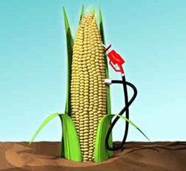
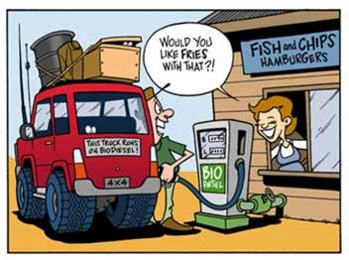

The following images can be used free, we bought the right to use them.
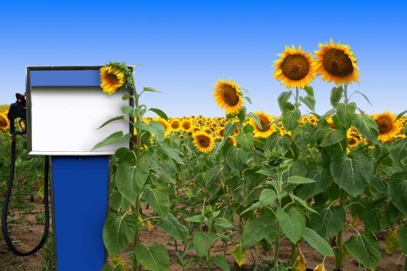
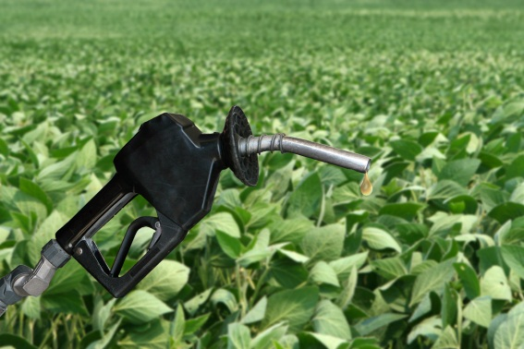

At the end of the forth class students are expected to be able:
- Understand the advantages and disadvantages in producing fuel from corn.
- Ask questions.
- Raise Ideas.

Activity 5- critical reading of a scientific article
Student should understand that newspapers don't always write reliable information. The students will be asked to read a text from a scientific article, interpret graphs and tables and reach conclusions.

At the end of the fifth class students are expected to be able:
- Understand the meaning of the text.
- Draw conclusions from reading the text and graphs.

Activity6- an experiment aimed at comparing the efficiency of fuels
The students will:
- Compare between gasoline, diesel and biodiesel (from used plant oil) by measuring the time which is needed to heat water to 60°C.
- Draw conclusions from their observation regarding the burning fuels.

At the end of the sixth class students are expected to be able:
- Record results and organize them in a table.
- Draw conclusions from Experimental results.

By the end of the module, students are expected to be able to:
Have a based opinion or decide which is the most effective fuel, and justify their opinion or decision on the basis of their knowledge during the implementation of the module.

Background material on the module:
Biodiesel is the name of an alternative fuel, produced from local renewable resources. Biodiesel is not a product from petroleum, but it can be mixed at any level with diesel to create a biodiesel mixture. It can be used in diesel engines with little or no changes. Biodiesel is simple to use, non-toxic, and does not contain sulfur or aromatic compounds.
Biodiesel is produced through a chemical process called transesterifcation in which glycerin is separated from fat or vegetable oil. The process leaves behind two products - methyl - ester (the chemical name for biodiesel) and glycerin (a valuable byproduct usually used to make soaps and other products).
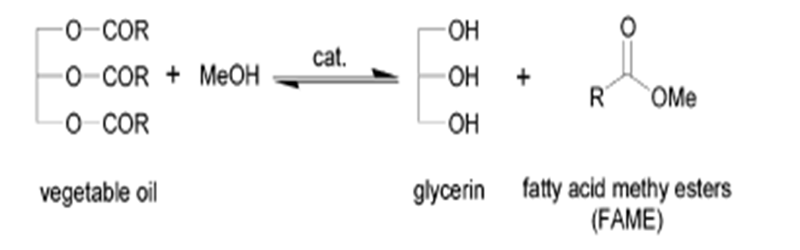
Biodiesel is defined as mono-alkyl esters of long chain fatty acids derived from vegetable oils or animal fats which are compatible for diesel engines. Biodiesel refers to the pure fuel before blending with diesel. Biodiesel blends are marked as "BXX" where "XX" represent the percentage of biodiesel contained in the blend (i.e.: B20 is 20% biodiesel, 80% diesel).
Biodiesel is better for the environment because it is made from renewable resources and has lower emission of pollutants gases compared to Petroleum and diesel. It is less toxic than table salt. It is made in the USA from renewable sources such as soybeans. The use of biodiesel reduces the use of petroleum.
Biodiesel is a bio-fuel, fuel that is produced from oils, not crude vegetable oil. It can be produced from vegetable oils (soybean, canola, coconut, corn, peanuts, etc.) or be recycled from frying oil and animal fat.
The first diesel engine, invented by Rudolf Diesel in 1892 was driven by peanut oil. Biodiesel can be used as a substitute for any diesel engine, without having to do any change in engine. Biodiesel can be used also for home heating. You can use any mixing ratio of bio - diesel and regular diesel, and use of bio - diesel only.
When you want to use 100% bio - diesel ("B100"), it is necessary to replace some pipes and plugs, which are made of nitric rubber, to more resistant materials because of his captivity - this rubber validity diesel. This investment is not large and worthwhile in the long run for those who plan to use bio - diesel over time.
Bio - diesel is not flammable, not toxic, biologically breaks down quickly and priced lower than gasoline or diesel fuel. Unlike the use of regular fuels, burning biodiesel contributes very little carbon dioxide into the atmosphere as plants which consume oil produced carbon dioxide in photosynthesis and thus overall contribution to greenhouse gases at least 80% greater than the fossil fuel. The degree of contribution of carbon dioxide into the atmosphere depends on the production process which may include use of methanol produced from crude oil and energy use in the production process itself. The amount of pollutants emitted from the combustion process of bio - diesel fuel is significantly lower, compared to gasoline and diesel fuel. Fossil diesel is not a renewable source. Demand for bio - diesel price increases in turn created which justified a focus on growing crops for production of bio - diesel. This reduced the volume of global food production and contributed, along with other factors, the rise in food prices in 2008.
Research shows that use of bio - diesel reduces engine depreciation, even if the bio - diesel mixed with regular diesel fuel, and improves engine performance. However, it can't be stored bio - diesel for more than one year. Another limitation of bio - diesel is moving at low temperatures because its viscosity is higher than that of diesel fuel, this can be solved by installing special equipment to promote - heating or diluting the bio – diesel.
In Europe are sold annually in Europe (2003) 1.9 billion gallons of bio - diesel, while the United States sold 56.8 million gallons per year. The price of a liter of bio - diesel in the United States was about half a dollar as of 2004. Brazilian gas stations can request the bio - diesel with ethanol produced from sugarcane.
In Israel one can purchase bio - diesel commercially. The first company engaged in commercial production of bio - diesel is Green - be (Green Be). In addition, there are workshops for making bio - diesel by recycling used cooking oil. The use of oils in bulk cheaper than use of diesel fuel. The cost of producing bio - diesel from clean vegetable oil is about 1 dollar per liter. The cost of used frying oil production is about 4 dollars a gallon. There are no significantly efficiency differences in efficiency between bio - diesel & diesel.

Assessment of activity of students

Activity 1 Scene .Introduction of the problem
Aspect | Criteria | Scores
Answers to questions | Answer the questions while demonstrating understanding and interesting of the problem  Give reasoned answers and explanation using correct scientific language | 10

Activity 2: Coparision of fuels.
Aspect | Criteria | Scores
Coparision of fuels | Select information sources  Organize information in appropriate table | 10
Inquiry’s questions | Answer the questions correctly  Draw conclusions based on the comparision | 10

Activity 4 –image interpretation
Aspect | Criteria | Scores
Looking at the image | Discussions in the group about the idia behind the image | 5
Questions | Ask relevant questions  Critical thinking and social skills | 5
Analysis of the picture | Written explanation of the problem depicted | 5

Activity 5- Scientific literacy
Aspect | Criteria | Scores
Analysis of scientific article | Informational text to search data(reading comprehension, reading graph) | 15

Activity 6 -Laboratory (teacher demonstration)
Aspect | Criteria | Scores
Water heating by different fuels | Observations  Organize the results in right table  Explain correctly the results | 5
Observing fuel Smoking | Write correctly the results  Organize the results on the table  Explain correctly the results | 5

Summary – Decisions and opinions
Aspect | Criteria | Scores
Questions | Answer the questions | 10
Analysis of results | Explain using correct scientific language  Show critical thinking | 10
Discussion summary | Draw conclusions based on all the above | 10

Acknowledgement:
The idea for the experiment of this module was taken from the Teaching-Learning Materials Tool compiled by the PARSEL Consortium (namly by Streller, Benedict, & Bolte, 2007) as part of the EC FP6 funded PARSEL Project (SAS6-CT-2006-042922-PARSEL) and adapted by the FUB-PROFILES Working Group – Member of the PROFILES Consortium. For further information see: www.parsel.eu.

