PROFILES IBSE Teaching/Learning Materials – Overview

Compiled by the PROFILES Working Group of the Weizmann Institute of Science, Israel

Can used oil be the next generation fuel?

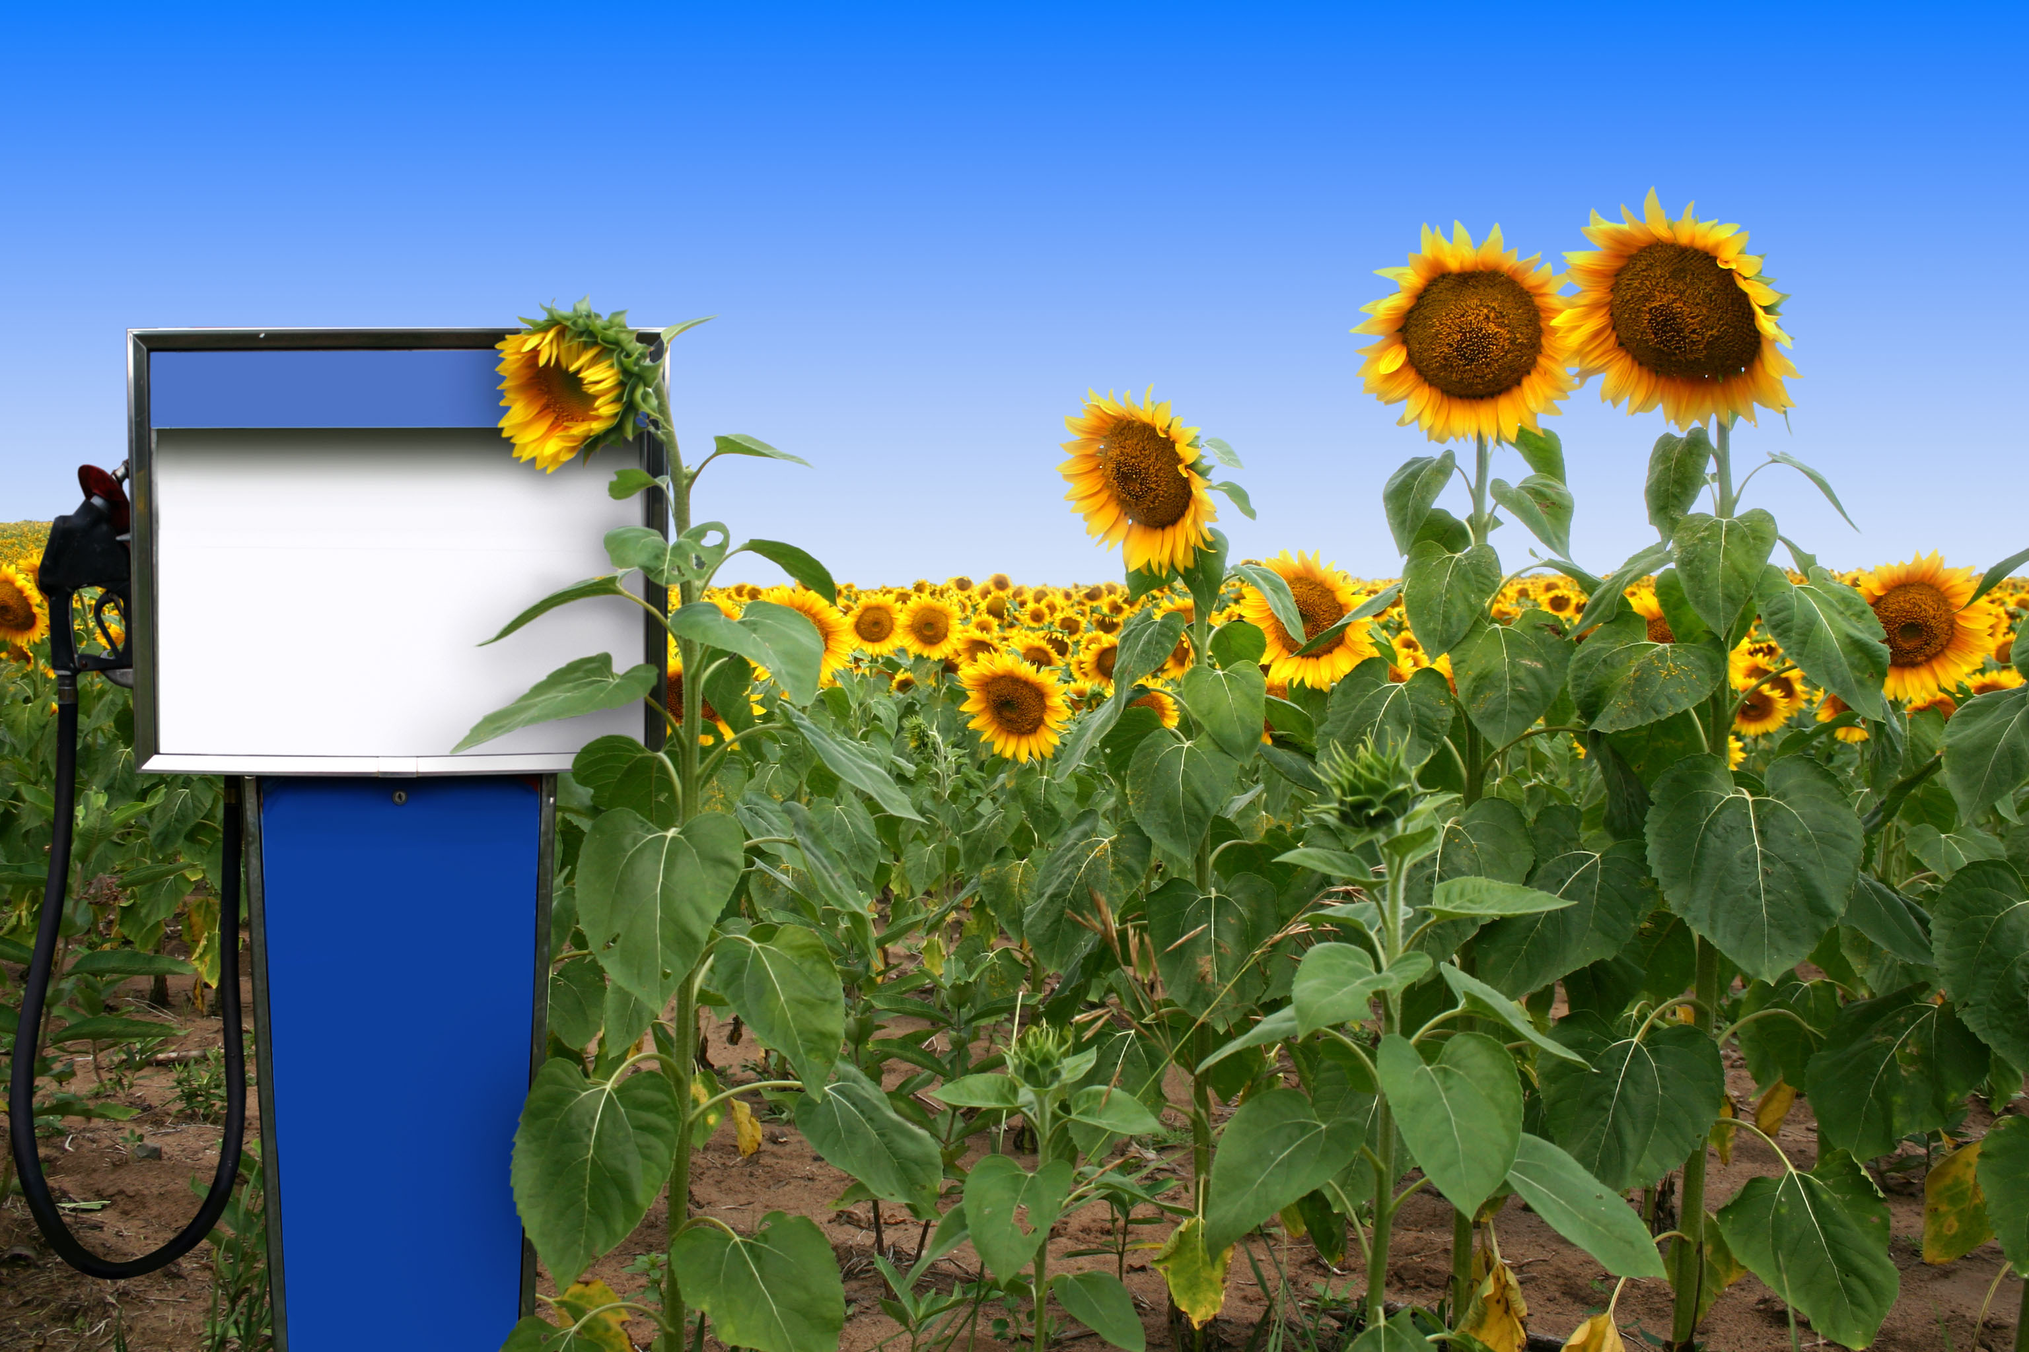

A Module for Science Instruction – especially Chemistry – for Grades 9 to 10

Leaders: Avi Hofstein and Rachel Mamlok-Naaman

Developed by: Lira Ezra, Bela Shkolnik, Jawad Agbaryia

Edited by: Dr. Dvora Katchevich and Dr. Rachel Mamlok-Naaman

Institution: Science Teaching Department, the Weizmann Institute of Science – Israel

Homepage: <http://stwww.weizmann.ac.il/g-chem/profiles/>

# Can used oil be the next generation fuel?

## Activity 1- Scene

Congratulations! 7 billion human beings are born!

Seven billion people that will grow up and each one will need food, water, car, house, but not everyone will be able to have them. World population has grown from two billion to seven billion people, between 1927 and 2011. However, the Earth is limited. The earth has a limited space, limited food; limited energy resources.The modern man uses energy in every daily activity, consciously or not. Every action requires the use of energy sources.

The main energy source used throughout the world is the "black gold" - petroleum. With the advance of technology the demand for petroleum is rising.

Oil, one of the substances in petroleum is a limited commodity ball - we've got oil only for the coming years .Moreover, as the use of energy sources increases, the air pollution is rising which can damage the quality of life and health of the creatures in the world.

We must save the Earth and maintain the air clean so that we and next generations can continue to live and enjoy! Let's search for alternative energy sources for a better future.

### Questions

1. List 5 questions that arise after reading the text.

2. What information is missing for you to answer the questions?

3. What associations arise in your mind with the word "fuel?"

4. List 10 actions that which involvethe use of an energy source.

5. In which actions in the previous question you need fuel?

6. According to the "Law of conservation of energy:” energy is not lost or created from scratch”. And yet there is "energy crisis". This crisis is very severe. How is this fact consistent with the conservation of energy? Explain.

7. Search for one article dealing with "energy crisis" - What is the problem that rose in the article? Is there any solution to the problem? If so, what is it?

8. Many countries make use of renewable energy sources. What are disadvantages of the use of renewable energy sources?

## Activity 2- Comparison of fuels

Samson has driven his private car for many years. He always uses gasoline 95. One day, Samson bought a taxi which uses "Diesel" eventhough it is the same model as his private car. Until that day, Samson did not know about the existence of different fuel types in the market. Samson's curiosity grew and he decided to read about fuels in order to broaden his horizons. But he's a very busy, spends his days in a taxi.

You have been chosen to help Samson to compare different fuels. In order to do this you can, go to the nearest gas station, find out prices and also search for the information online.

You may use the table in order to organize the information you have gathered.

#### Comparison table of fuels

|  |  |  |  |
| --- | --- | --- | --- |
| Gasoline | Diesel | ביודיזלראשהטופס  Biodiesel  מילון  gasoline  petrol  gas  benzene  תחתיתהטופס | Criteria |
|  |  |  | Price |
|  |  |  | Products of combustion |
|  |  |  | Suitable for |
|  |  |  | Energy released per liter fuel that burns |
|  |  |  | Production methods |
|  |  |  | Boiling Point |
|  |  |  | Chemical composition |
|  |  |  | State of matter |
|  |  |  | Pollutant emissions |
|  |  |  | Other |

Answer the following questions in your group and decide which is the best fuel.

### Questions:

1. Burning a liter of "Diesel" releases more energy than burning a liter of "Octane 95". Still, private vehicles are prohibited from using diesel. Explain.

2. Based on the table above make a list of advantages and disadvantages of each fuel.

3. Decide which is the best fuel. Provide at least 3 reasons.

## Activity 3- Experiment design

Design an experiment which will test the effectiveness of various fuels.   
You must design an experiment according to the stages of scientific inquiry.

1. Define the hypothesis. Base it on previous scientific knowledge.   
   Explain your hypothesis!
2. What is the dependent variable in the experiment?
3. What is the independent variable?
4. What are the conditions which you must keep constant during the experiment?
5. List the equipment and materials needed for your experiment.
6. Design the procedure of the experiment.

## Activity 4- Image interpretation

1. Look at the following image.

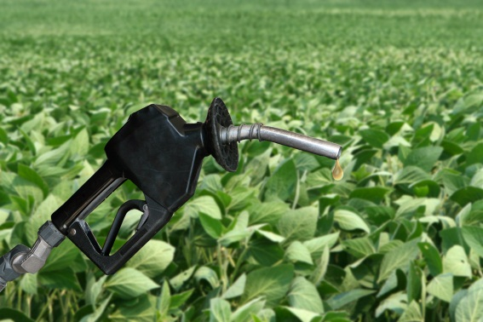

1. What is the main idea behind the image?
2. Write five questions that interest you related to the idea behind the image.
3. Each group member will write 2-3 things he learns from the image.
4. The image deals with biodiesel.
   1. Does the image show advantages of biodiesel?   
      If so, what are the advantages?
   2. Does the image show disadvantages of biodiesel?   
      If so, what are the disadvantages?

## Activity 5- critical reading of a scientific article

Read the following text and answer the questions:

### Corn: is it good only as food?

Jack, a farmer, threw into the fireplace in his house several dried corncobs. Flames were flickering, the fireplace and the glass door that separates the combustion chamber from the room remained clear there were no traces of soot. "Look," said Jack, "this is a perfect combustion".

By this short demo Jack wanted to show his family that corn can be used as fuel, it releases energy when burned. Jack pointed out that fuel can be produced from corn -"biodiesel" (bio =natural) and this fuel may be an important and commom energy source. Corn is used as fuel to provide energy to cattle as food, but it can be used to provide energy for transportation.

Another fuel that can be derived from natural sources is ethanol, CH3CH2OH, which burns without producing pollutants. In order to reduce the dependence on petroleum, air pollution and fuel prices, many countries in Central America began to grow strains of corn that are more suitable for producing ethanol.

Despite the advantages of fuel from corn and sugar cane there are some disadvantages. The production of ethanol and biodiesel from corn could rise the cost of food and encourage farmers to destroy natural areas - deforestation.

One of the solutions proposed and tested in recent years is the production of biodiesel from used oil. Apparently used oil is valuable! you can buy it in quantities from fast food stores. Eventhough used oil is not healthy for the human body, it is effective for cars. This would not affect areas that are designed for growing food and more over even be able to prevent the discharge of oil into the sink and reduce ground water pollution.

### Questions

1. Fuel that is produced from corn has many advantages.   
   Write three advantages.
2. What problems may arise the use of fuel from corn?   
   Explain two problems.
3. Jack points out that corn is used as an energy source. What are two main processes, described in the article, in which corn is used as an energy source? Explain.
4. Jack is considering to grow strains of corn that are more suitable for transportation than those he has been growing which are used to feed animals. What would you suggest him? explain
5. Complete: One molecule of ethanol consists of:  
    _Carbon atoms _ Hydrogen atoms. _Oxygen atoms.
6. Write the balanced reaction of ethanol combustion.
7. The chemical formula of regular diesel is C16H32(l).   
   Write the balanced reaction of C16H32(l) combustion.
8. Based on your answers to the two preceding questions, which of the combustion processes releases a larger amount of Carbon Dioxide, for each molecule that burns, diesel or ethanol? Who pollute the environment more?
9. About 10 years ago the U.S. began to produce bio - diesel from corn. The following graph depicts the amount of biodiesel produced in the United States in the period between 1999-2007.

תיאור: תיאור: 34-MAD-010-8A-Sofi-q10-new

Milion liters

The year

U.S. biodiesel production (million liters)

#### According to the graph:

1. Between what years was the largest increase in the amount of bio-diesel produced in the U.S.?
2. Between 2003 and 2004
3. Between 2004 and 2005
4. Between 2005 and 2006
5. Between 2006 and 2007
6. Danny says that according to the trend of the graph you can conclude that the amount of bio-diesel generated in the U.S. in 2012 will be greater than 2,000 million liters. Do you think Danny is right? Explain your answer based on data in the graph.

## Activity 6

### Procedure of the experiment

In the experiment you will compare the combustion of three types of fuel in order to check their efficiency.

* Cup A contains biodiesel - used oil fuel produced.
* Cup B contains diesel
* Cup C contains gasoline 95

#### . Part 1:

1. Mark the burners: A,B,C respectively.
2. Measure 250 ml of fuel and fill the burner with it.
3. Measure the mass of the burner containing the fuel. Fill the data in the following table.

|  |  |  |  |  |
| --- | --- | --- | --- | --- |
| Fuel type | mass of the burner and fuel before combustion (gr) | mass of the burner and fuel after combustion (gr) | Time that takes the water to reach 600C | Mass fuel that reacted |
|  |  |  |  |  |
|  |  |  |  |  |
|  |  |  |  |  |
|  |  |  |  |  |

\**Note: after the combustion process we have to calculate the mass loss of fuel*

#### Part 2:

Note that All conditions in experiment should be the same. Follow the instructions and write the results in the table.

1. Fill a beaker with 400 ml distilled water.
2. Measure the initial temperature of the water___.
3. Light the first burner containing the fuel, measure the temperature that takes the water to reach 60 degrees Celsius.
4. Repeat Step 1,2,3 with two additional fuels.

### Questions for part 2:

A. What are the two variables tested in the experiment?

Which is the dependent and which is the independent variable?

B. Which conditions were mantained constant? Why is this important?

C. Based on the results – which fuel lost the least fuel mass?

D. Based on the results which fuel heats the water in the shortest time?

E. What can we learn from these results on the fuel efficiency?

### Part 3

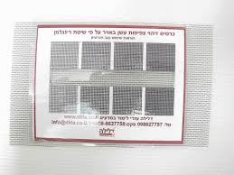In order to determine the degree of air pollution by a burning fuel, a Ringrlman board can be used.

A Ringrlman board is a plate which is used to determine the degree of air pollution in terms of combustion products and soot particles on the basis of comparing the smoke rising from the flame of combustible material (fuel types in this case( with the black squares in the board.

### *Procedure:*

1. Light the burner.
2. Look at the smoke through the slot of the Ringlman board.
3. Determine the degree of air pollution by comparing the smoke to the black color in the Ringlman board.
4. Repeat the procedure with all fuels.
5. Organize your observations in a table.
6. Based on observations which is the most polluting fuel?

**Acknowledgement:**

The idea for the experiment of this module was taken from the Teaching-Learning Materials Tool compiled by the PARSEL Consortium (namly by Streller, Benedict, & Bolte, 2007) as part of the EC FP6 funded PARSEL Project (SAS6-CT-2006-042922-PARSEL) and adapted by the FUB-PROFILES Working Group – Member of the PROFILES Consortium. For further information see: www.parsel.eu.